# **What is Jenkins?**

1. Jenkins is an open source **automation tool** used to **build and test software** projects.
2. This tool makes it easier for the developers to integrate changes in the project.
3. Jenkins is an **open-source** solution comprising an automation server to enable continuous integration and continuous delivery (CI/CD), automating the various stages of software development such as build, test, and deployment.
4. Jenkins is a **Java-based open-source automation platform** with plugins designed for continuous integration. It is used to continually create and test software projects, making it easier for developers to integrate changes to the project and for consumers to get a new build.
5. Organisations may use Jenkins to **automate** and **speed up** the software development process. Jenkins incorporates a variety of development **life-cycle operations**, such as **build, document, test, package, stage, deploy, static analysis**, and more.
6. Key benefits of Jenkins is **Plugin availability**.

# **Why to use Jenkins?**

1. Easy Interface
2. Easy to navigate
3. Easy Document and example
4. Free and Open source
5. Plugin and functionality
6. Users around the world

# **What is CI/CD Pipeline?**

1. **Continuous Integration:-**Continuous Integration is a process of integrating code changes from multiple developers in a single project many times. The software is **tested immediately** after a code commit. With each code commit, code is **built and tested**. If the test is **passed**, the build is tested for **deployment**. If the **deployment** is **successful**, the code is **pushed** to **production**.
2. **Continuous Delivery**:-Continuous Delivery is a process, where code **changes** are **automatically built, tested, and prepared** for a **release to production.**

Continuous delivery **automates** the entire software **release process**. Every revision that is **committed triggers** an automated flow that **builds, tests, and then stages the update**. The final decision to **deploy** to a **live production** environment is triggered by the developer.

# **Difference Between Continuous Integration.Continuous Delivery and Continuous Deployment**

| **Continuous Integration** | **Continuous Delivery** | **Continuous Deployment** |
| --- | --- | --- |
| Automated build for every commit | Automated build and UAT(User Acceptance Testing) for every commit | Automated build, UAT and release to production for every commit |
| Independent of Continuous Delivery and Continuous Deployment | It is the next step after Continuous Integration | it is one step further Continuous Delivery |
| By the end, the application is not in a condition to be released to production | By the end, the application is in a condition to be released to production. | The application is continuously deployed |
| Includes Whitebox testing | Includes Blackbox and Whitebox testing | It includes the entire process required to deploy the application |

# **How does Jenkins work?**

Jenkins is a **server-based application** and requires a **web server** like Apache **Tomcat** to run on various **platforms** like **Windows, Linux, macOS, Unix**, etc. To use Jenkins, you need to create pipelines which are a series of steps that a Jenkins server will take. Jenkins **Continuous Integration Pipeline** is a powerful instrument that consists of a **set of tools designed to host, monitor, compile and test code, or code changes**, like:

1. **Continuous Integration Server** (Jenkins, Bamboo, CruiseControl, TeamCity, and others)
2. **Source Control Tool** (e.g., CVS, SVN, GIT, Mercurial, Perforce, ClearCase and others)
3. **Build tool** (Make, ANT, Maven, Ivy, Gradle, and others)
4. **Automation testing framework** (Selenium, Appium, TestComplete, UFT, and others)

## **Work Flow of Jenkins:-**

1. First of all, a developer commits the code to the source code repository. Meanwhile, Jenkins checks the repository at regular intervals for changes.
2. Soon after a commit occurs, the Jenkins server finds the changes that have occurred in the source code repository. Jenkins will draw those changes and will start preparing a new build.
3. If the build fails, then the concerned team will be notified.
4. If build is successful, then the Jenkins server deploys the built in test server.
5. After testing, Jenkins server generates feedback and then notifies the developers about the build and test results.
6. It will continue to verify the source code repository for changes made in the source code and the whole process keeps on repeating.

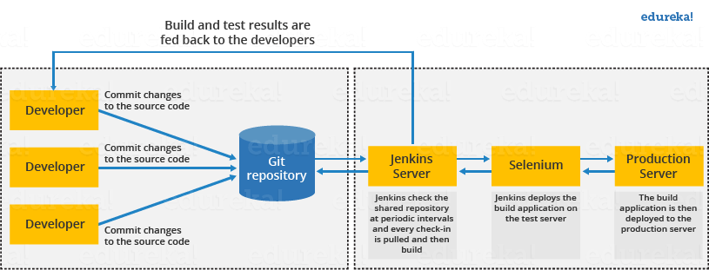

# Installation of Jenkins on Windows?

1. Navigate to the official site of jenkins.io and press download

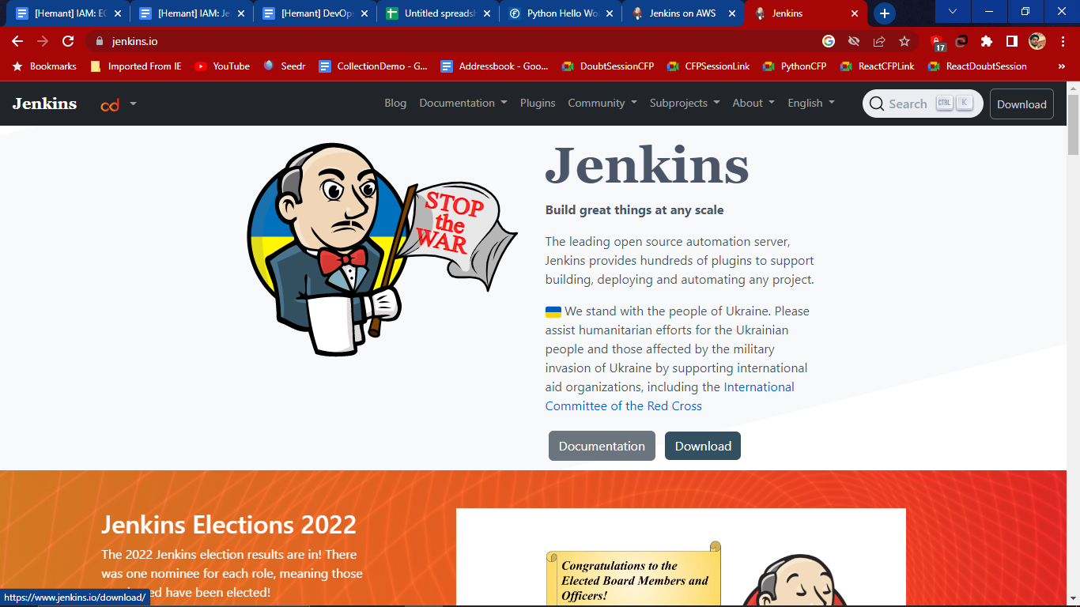

1. Select Stable LTS version- To install we have to install java 8 in our system and check the requirements then click on download link of LTS and download will start.

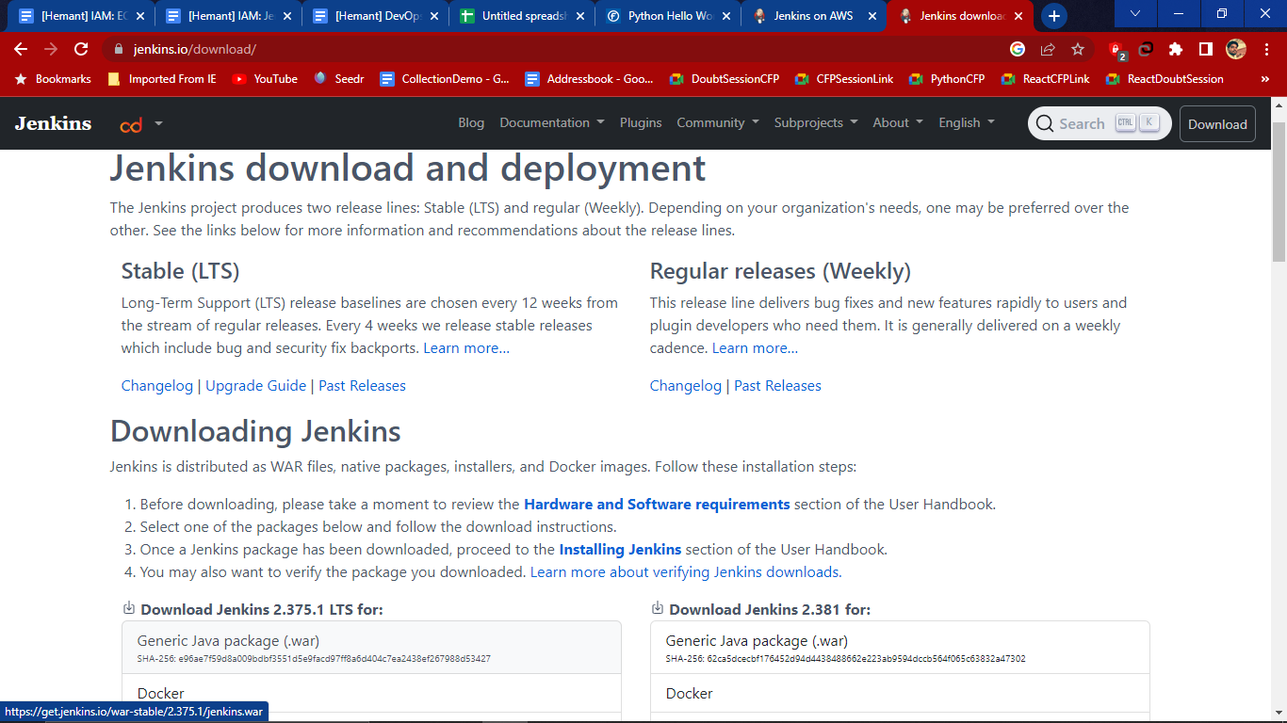

1. Now to check the version of java which is installed in our system by using windows powershell.If the java version is not installed in the system then download java from the site.

Then in powershell use command- **java -version** = to check the version of java

Then **java -jar <path of the jenkins file in .war format>** i.e

**java -jar E:\Jenkins\jenkins.war** then hit enter to install the jenkins into the system. **(jenkins.war)** downloaded from the jenkins.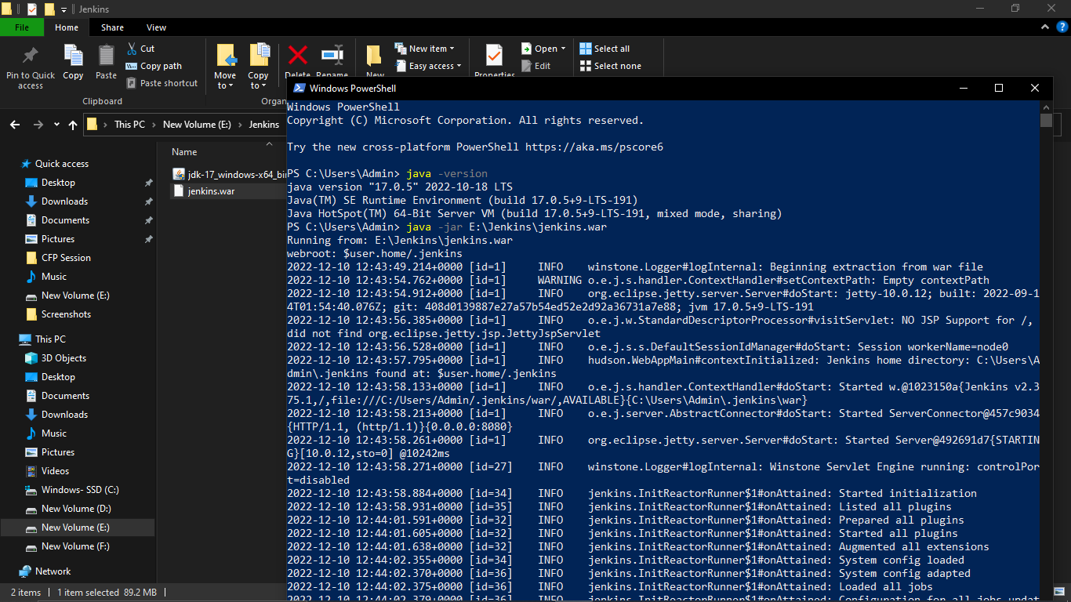

Here jenkins installed in the system when it shows successful

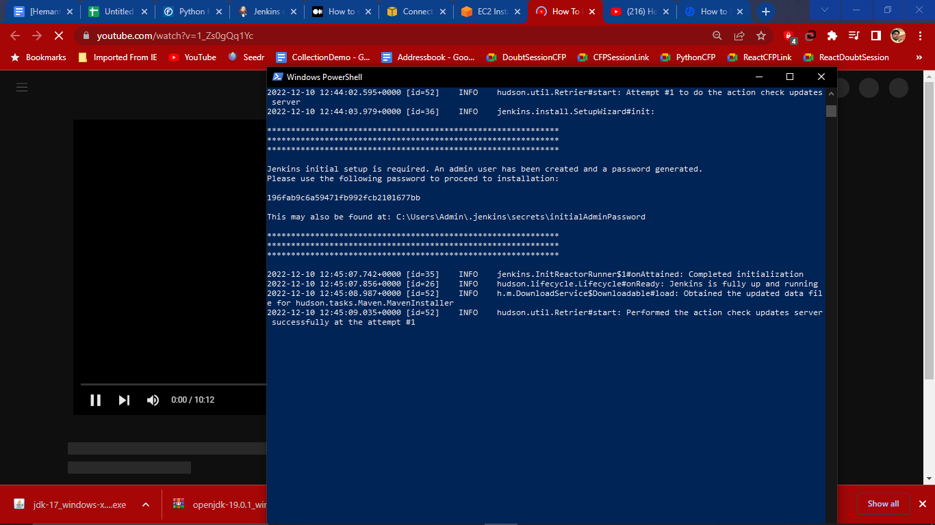

1. Here key is generated which we can use enter credentials in the jenkins page when it asked for the password

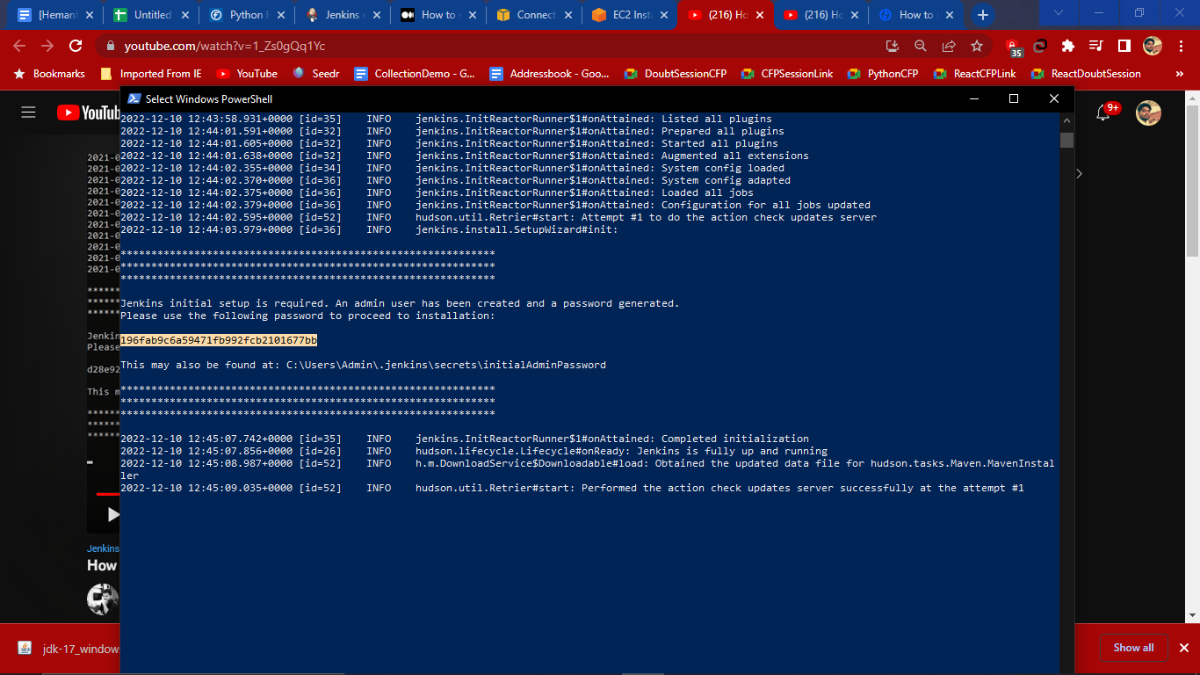

1. We can also find this key in the path **C:\Users\Admin\.jenkins\secrets\initialAdminPassword**

And if we open the file we get same key

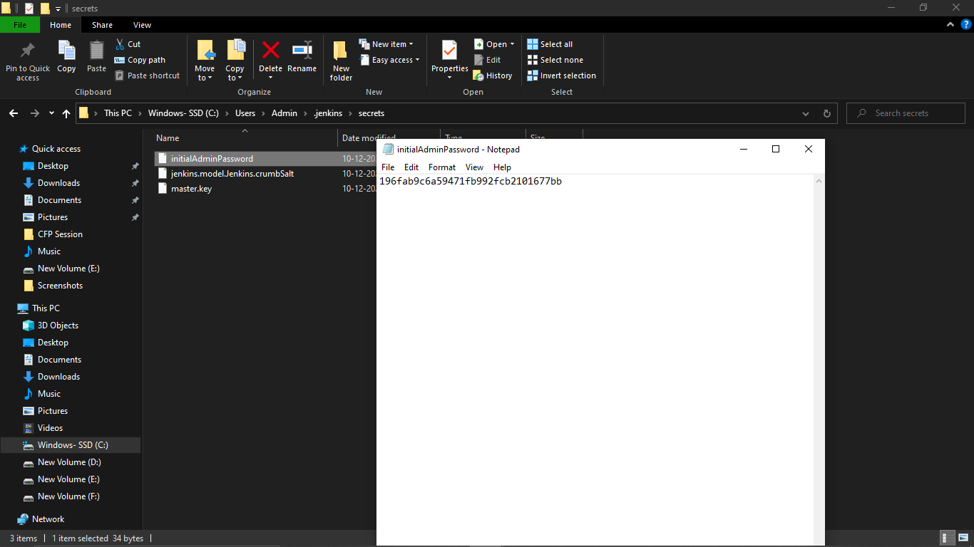

1. Then check on localhost:8080 by typing manually in the browser, we will get the page of jenkins and paste a secret key inside the password and hit continue

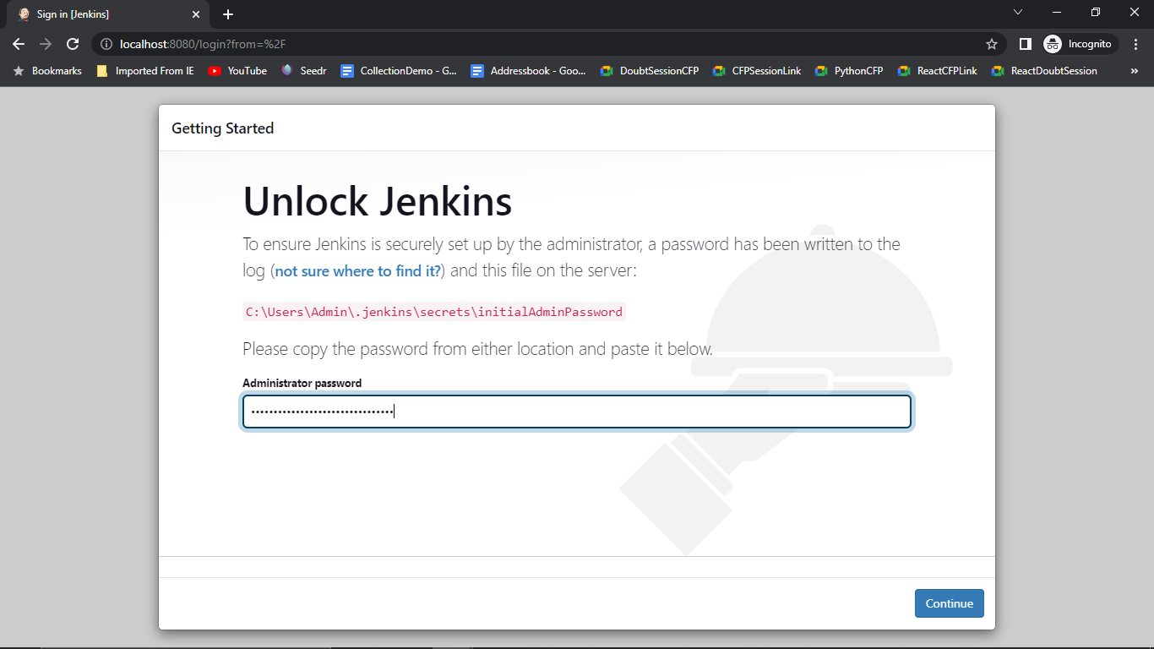

1. We will get the new page then install suggested plugin and it will download

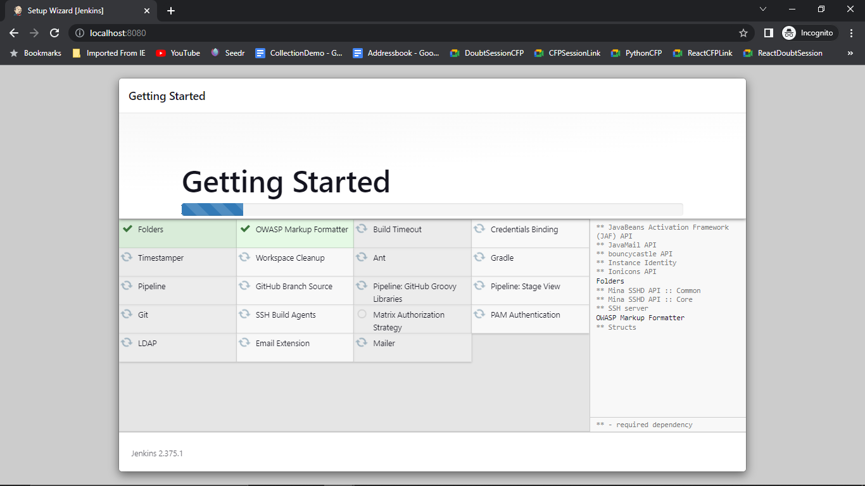

1. After getting all the things then create First Admin User

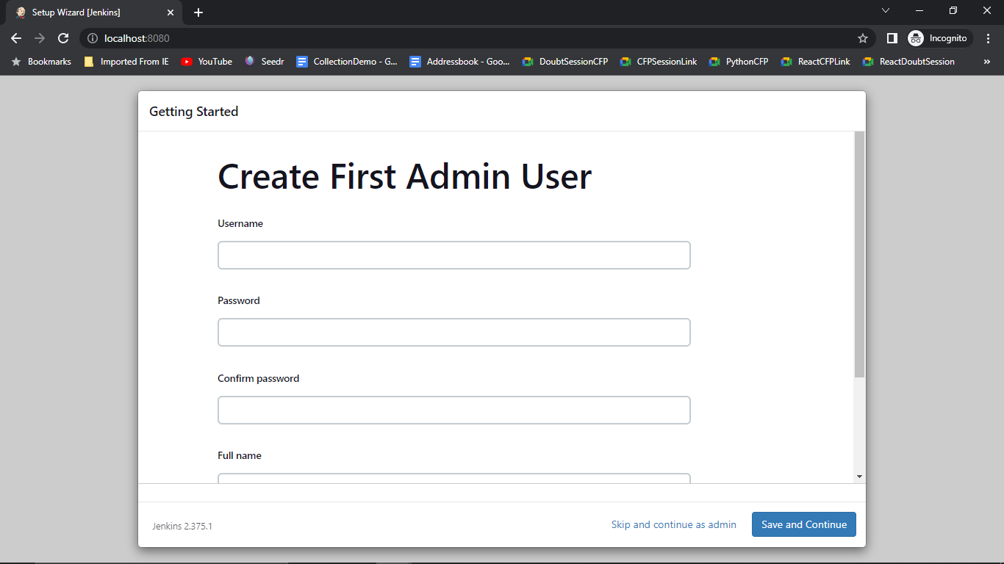

1. Create any user manually with our own password and email and then click on Save and Continue

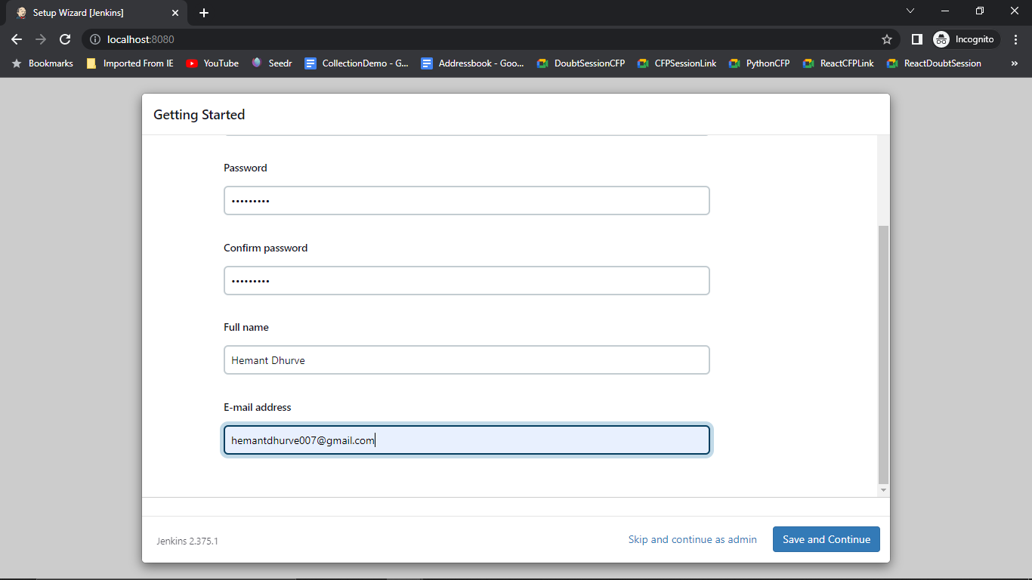

1. After in the Instance Configuration jenkins instance is running on the localhost:8080 port . we can also change the port which creating else leave as it is. Then click on Save and Finish.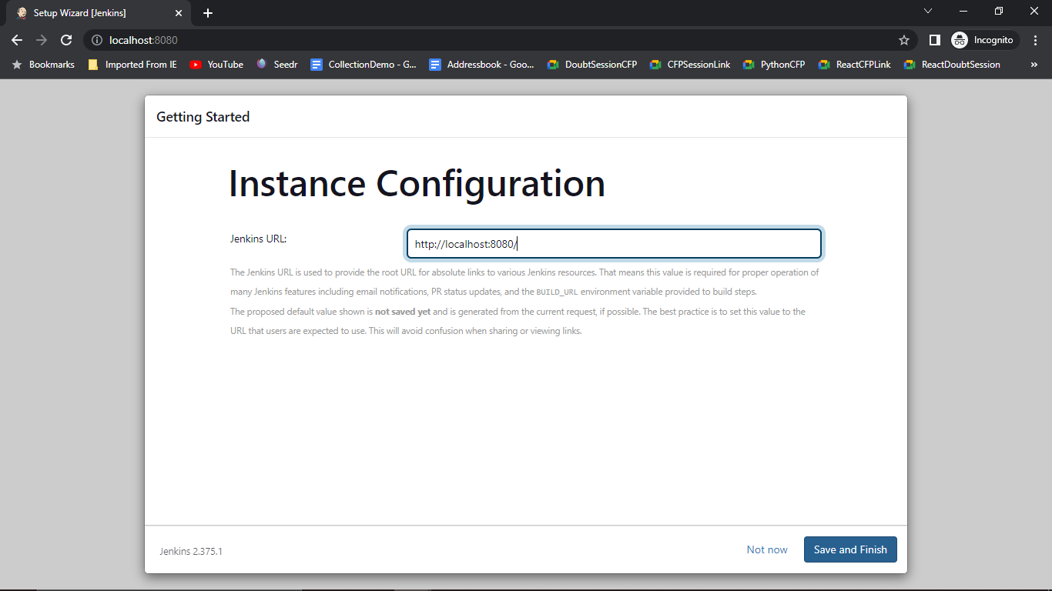 After hitting save jerkins is ready to start using

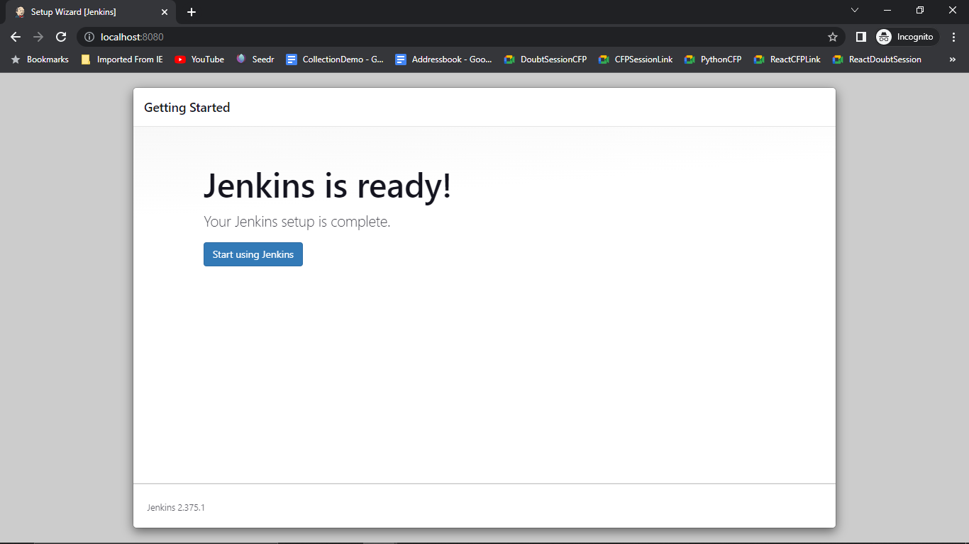

1. We will get the dashboard of the jenkins with a version 2.375.1

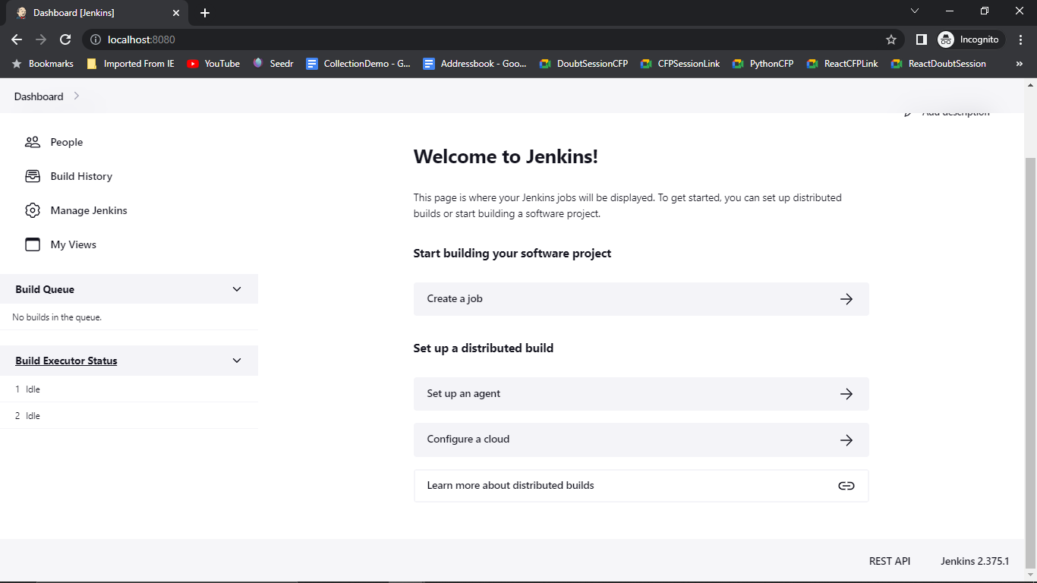

# 

# 

# 

# 

# **Installing Jenkins on AWS EC2? (Ubuntu)**

1. Log into your amazon aws console and launch a new EC2 instance. We will be using the Ubuntu 22.04 LTS for our EC2 instance.

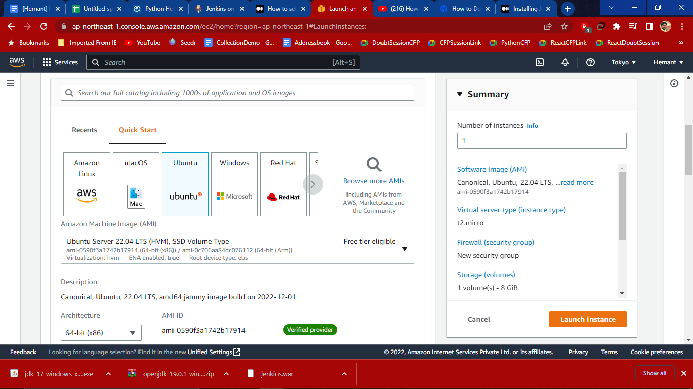

1. Create new Key and do changes in Network setting

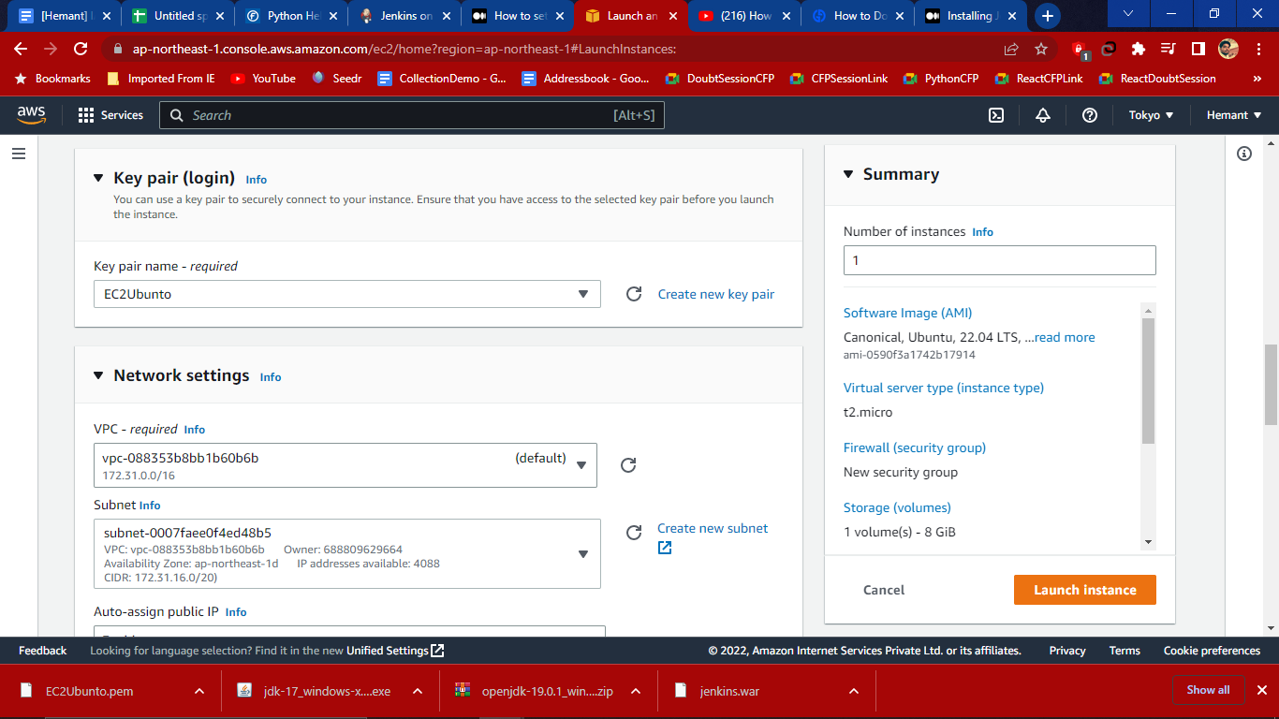

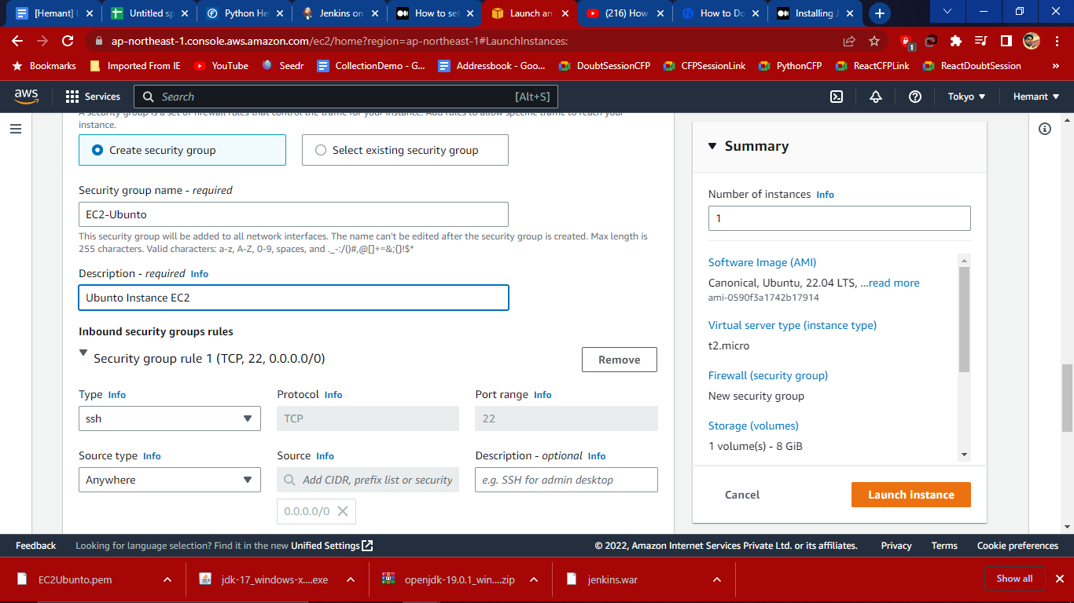

1. After creating instance connect to the instance and open terminal and write a command sudo apt update

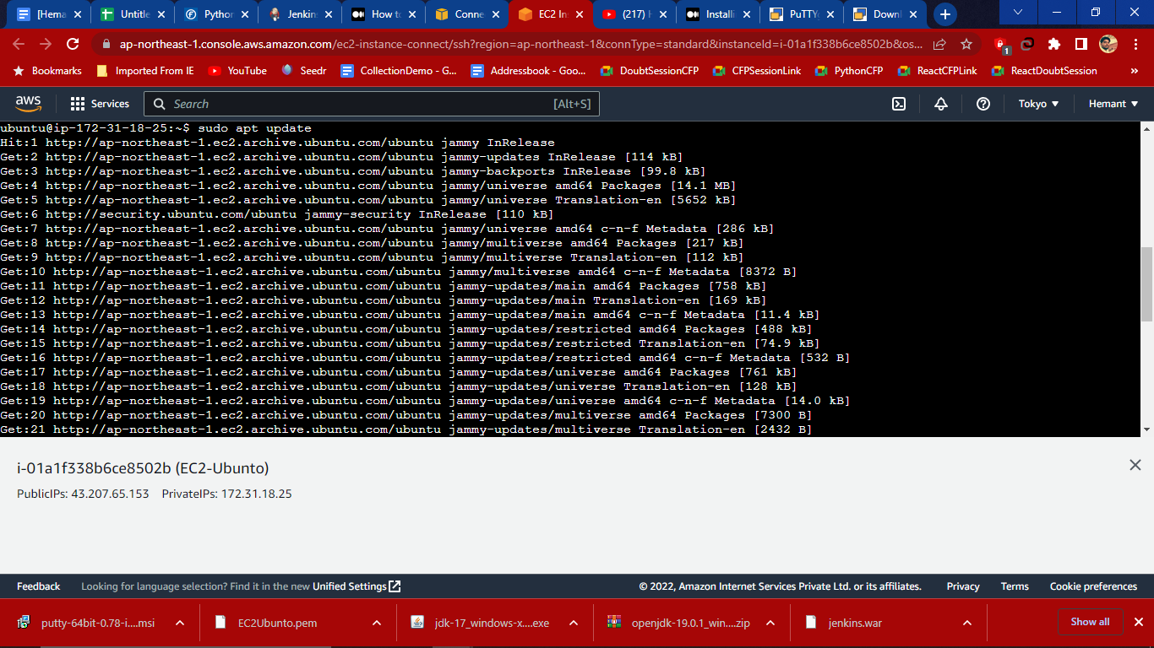

1. Now download jre for the jenkins by using this command-

**Sudo apt install openjdk-11-jre** then hit enter here java is now installing



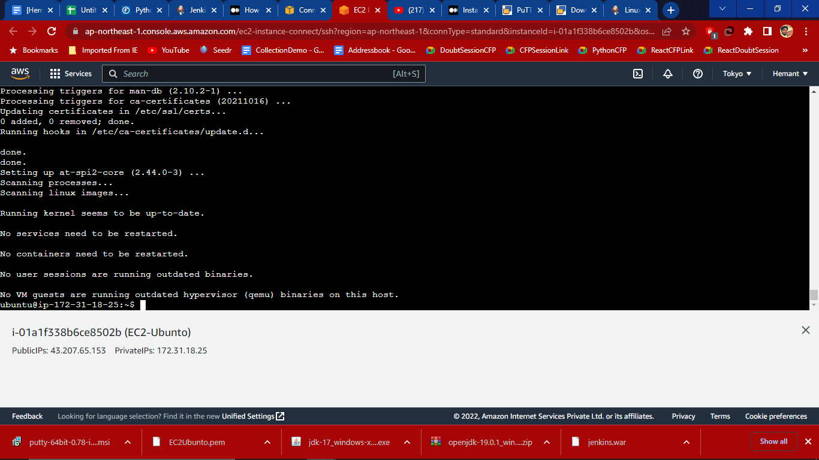

Here downloading of Java version 11 is installed successfully

1. Check for the version which we have just installed using- **java -version**

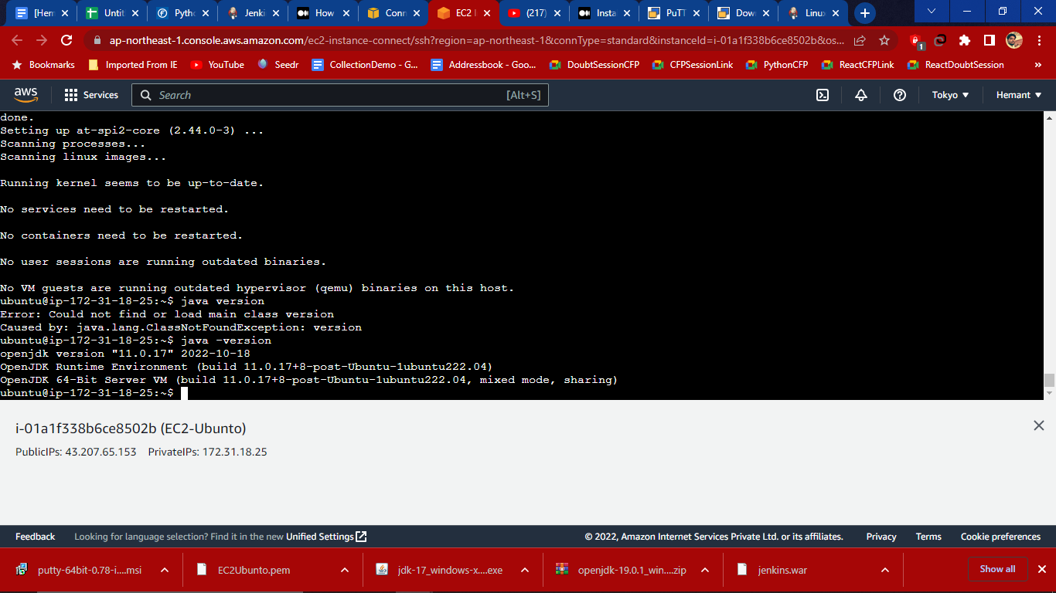

1. From the weekly Release -A new release is produced weekly to deliver bug fixes and features to users and plugin developers. By using command

**curl -fsSL https://pkg.jenkins.io/debian/jenkins.io.key | sudo tee \**

**/usr/share/keyrings/jenkins-keyring.asc > /dev/null**

1. Then use another command as-

**echo deb [signed-by=/usr/share/keyrings/jenkins-keyring.asc] \**

**https://pkg.jenkins.io/debian binary/ | sudo tee \**

**/etc/apt/sources.list.d/jenkins.list > /dev/null**

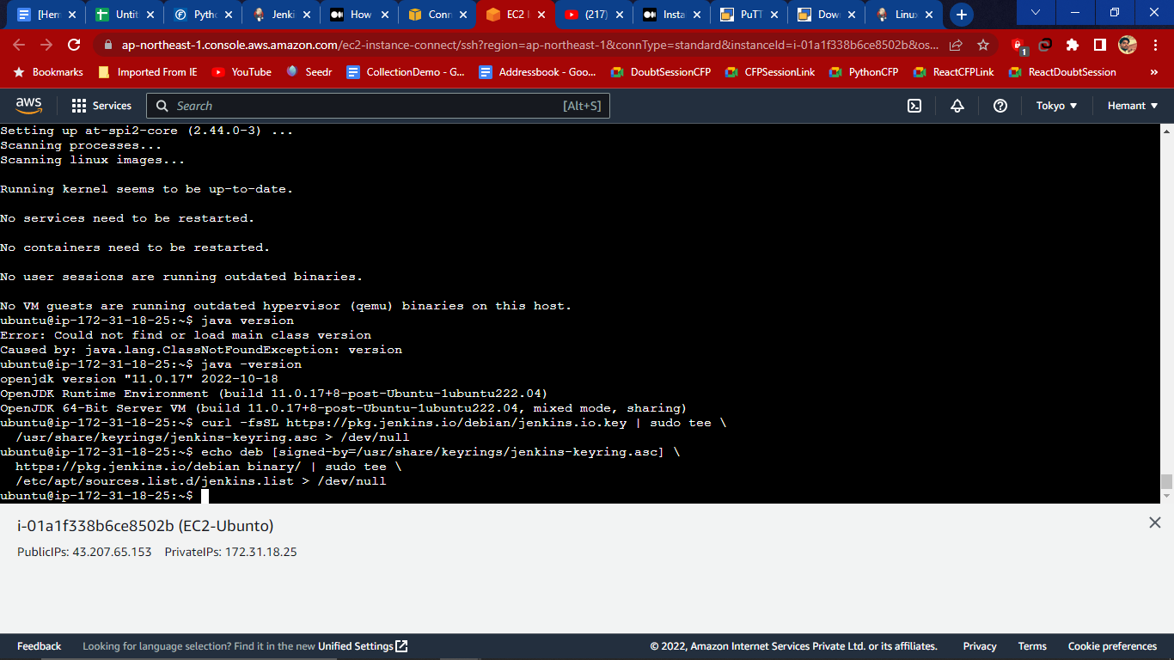

1. Use command to update- **sudo apt-get update**

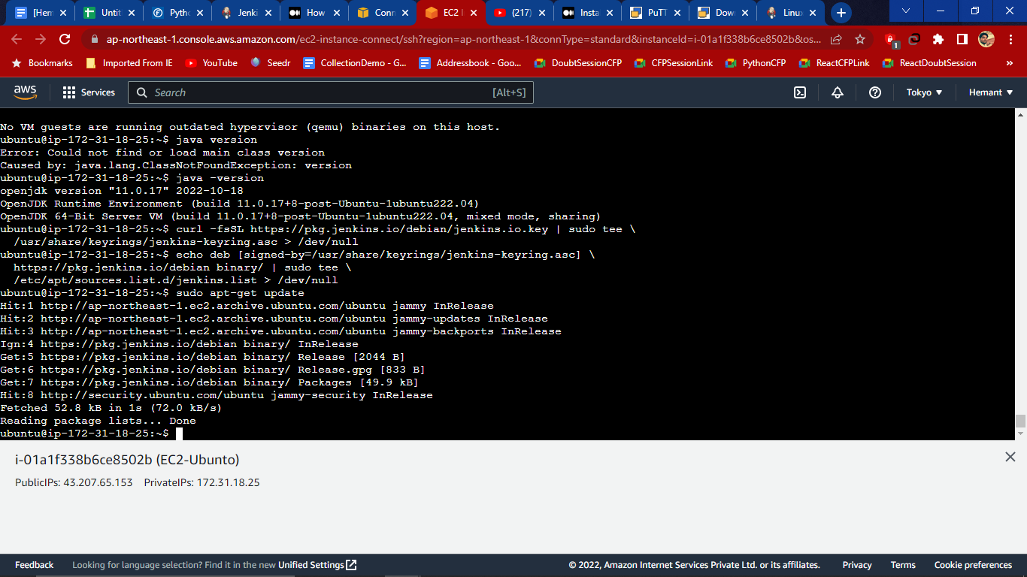

1. Last use the command to install jenkins as- **sudo apt-get install jenkins**

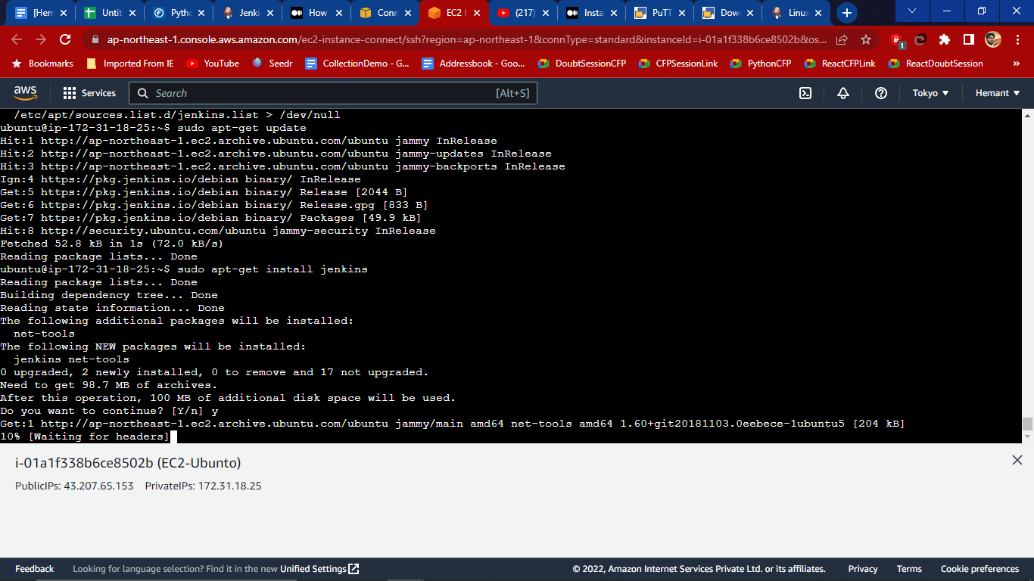

1. Now go the instances and under security and security group click on the link **sg-05374000d434dd900**

Here default port is 8080 so we need set inbound rules by clicking above link

under security and add inbound to it by clicking Edit inbound rules

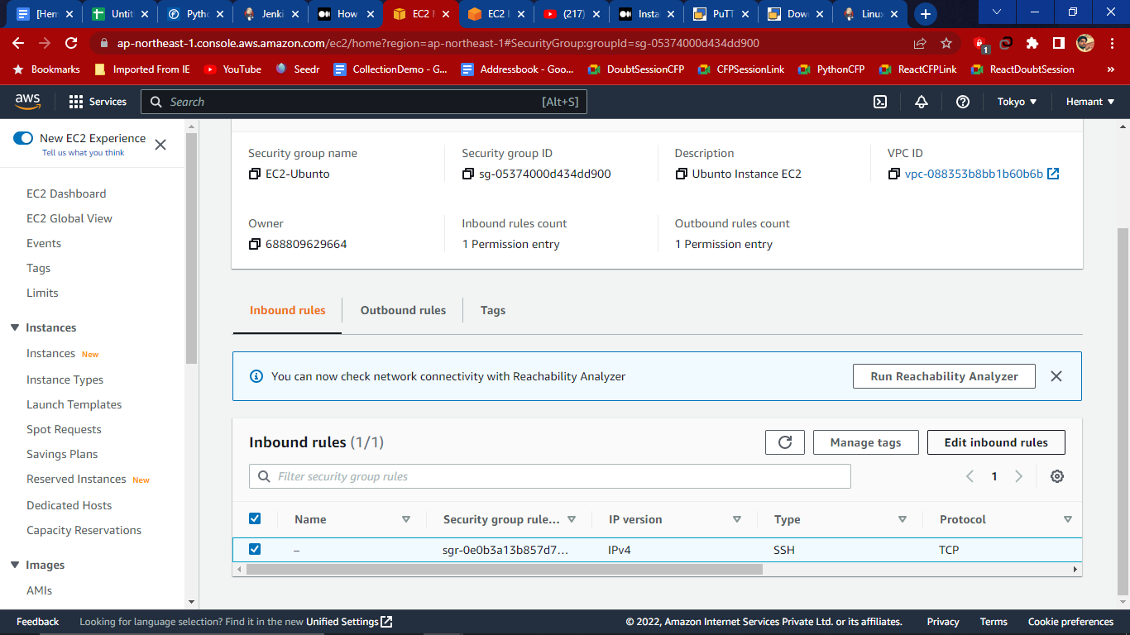

1. Then click on Add and then type port range **8080** with source **0.0.0.0/0**

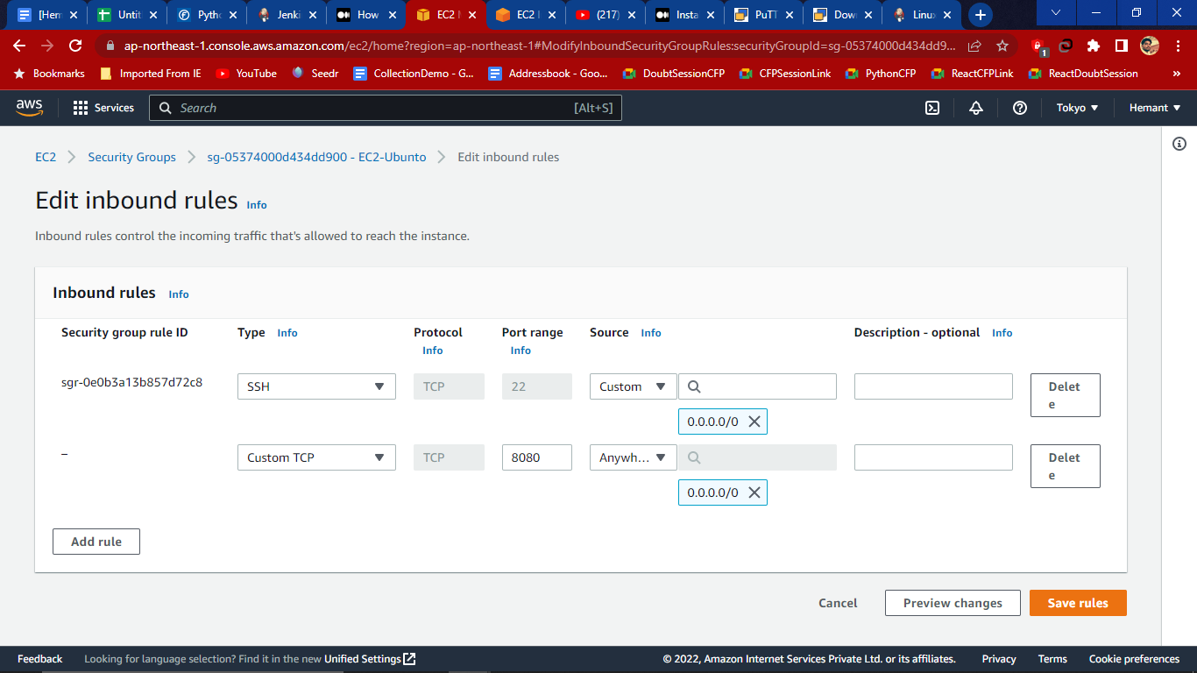

Then save the rules and we get 2 inbound rules

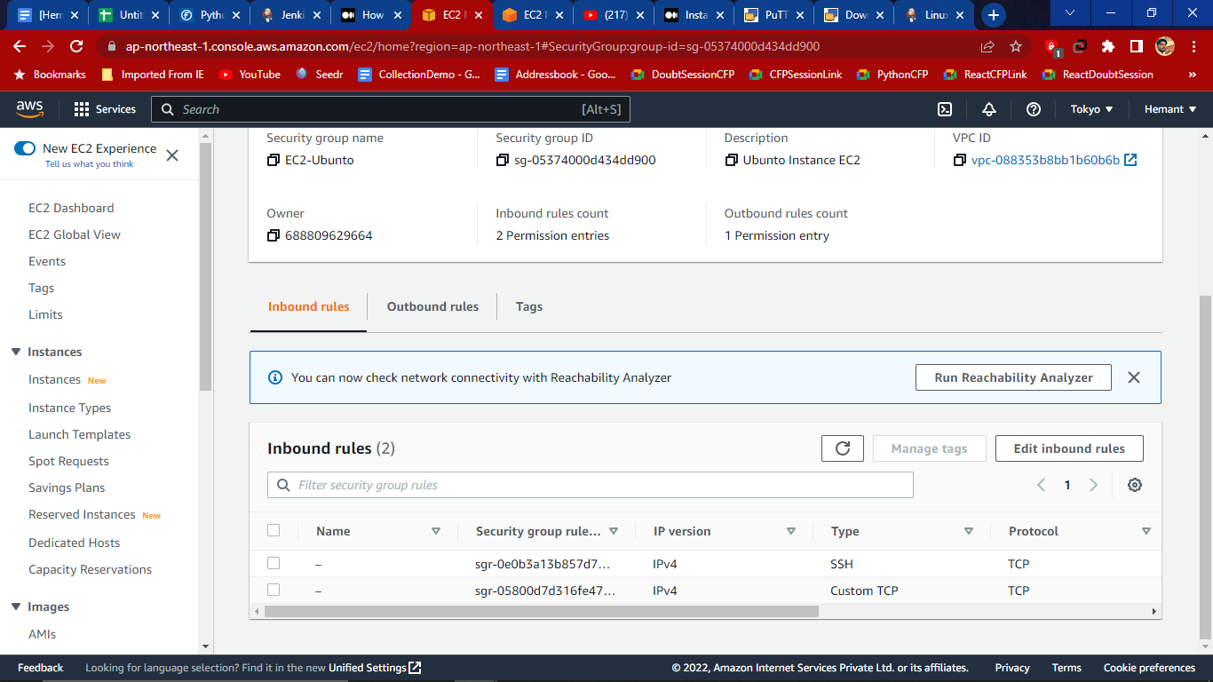

12.Then go to the EC2 and click on the instance that we are working on, we will get the new link in the public IPv4 DNS as **1.compute.amazonaws.com** then open link.

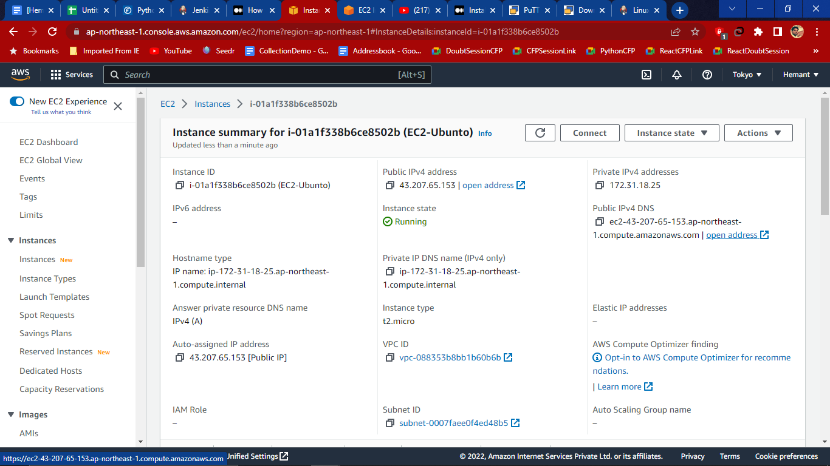

13. When clicking on the link it’ll not work on https so we have to run on **http://** and **:8080** add portal to run the link

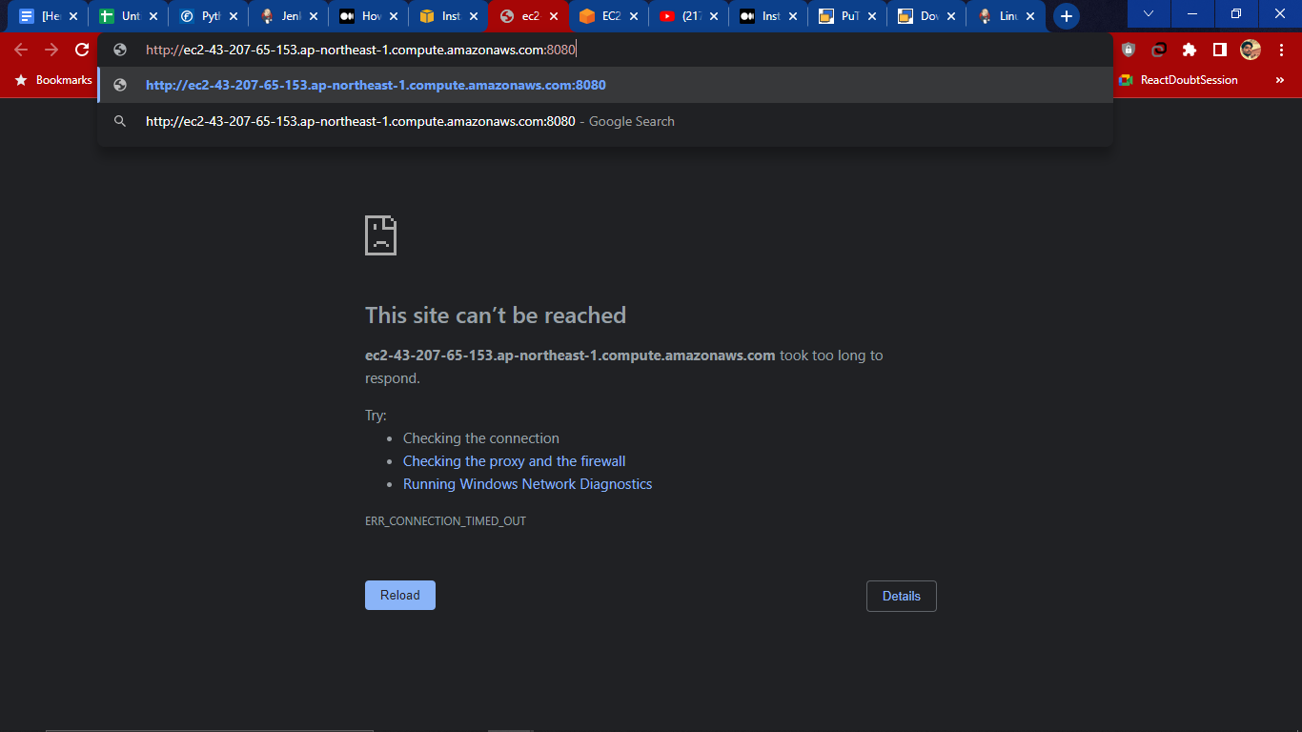

14. Now we get the jenkins page for now we dont have a password so click on the- (**not sure where to find it?)**  Link

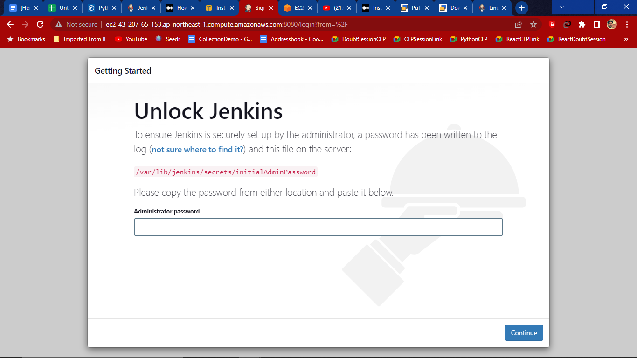

We will get a new tab and from here use the command-

**journalctl -u jenkins.service.** Andpaste in the terminal of EC2

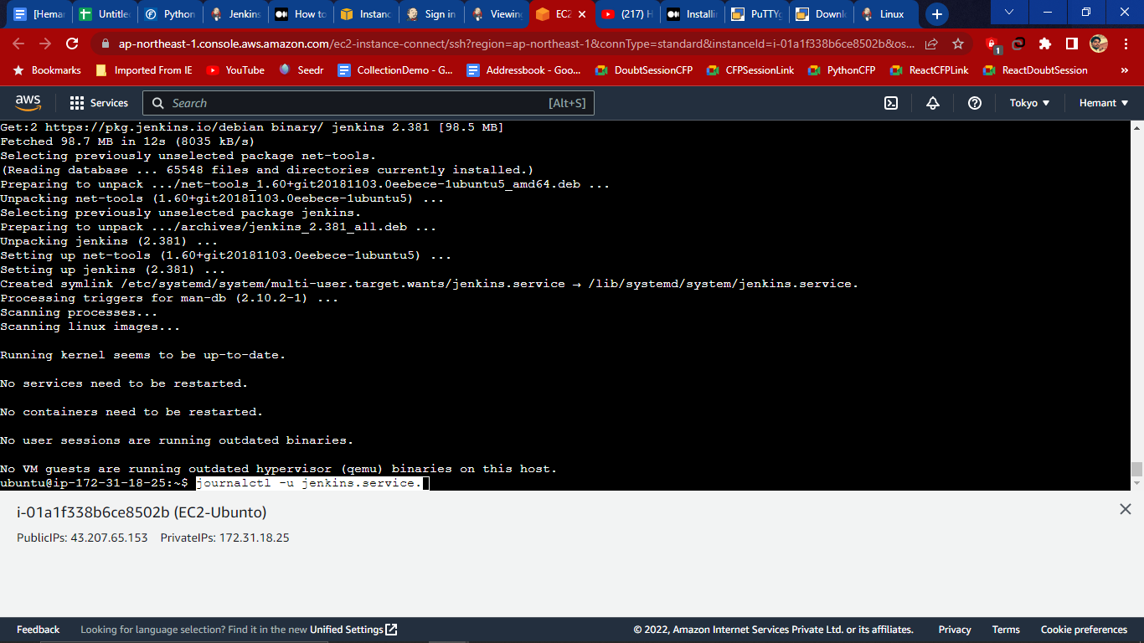

15. From here we will get the password which is one time use to create

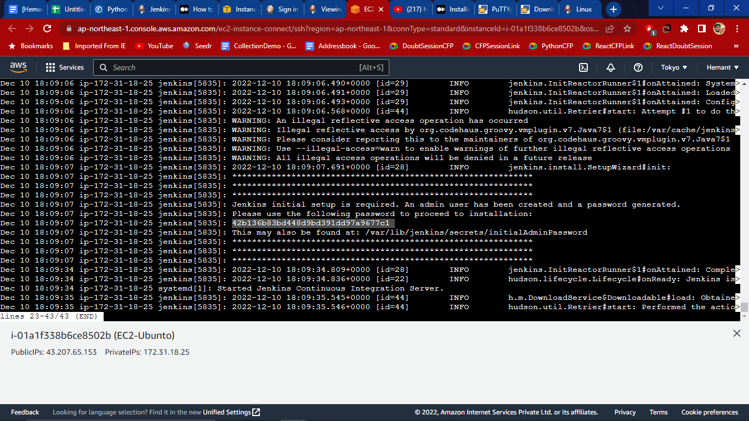

16. Now paste this password and hit continue

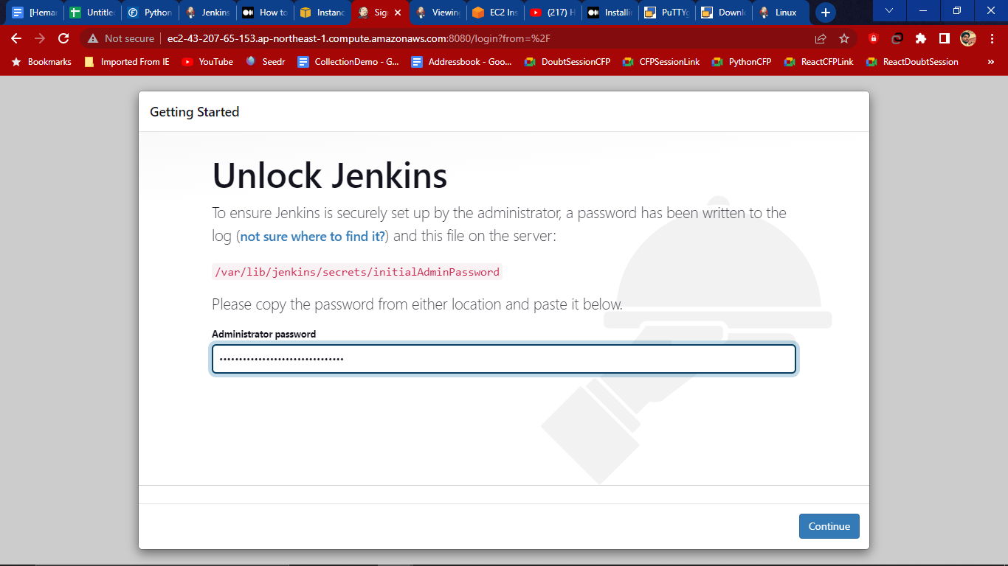

17.Click on Install suggested plugins and let it install

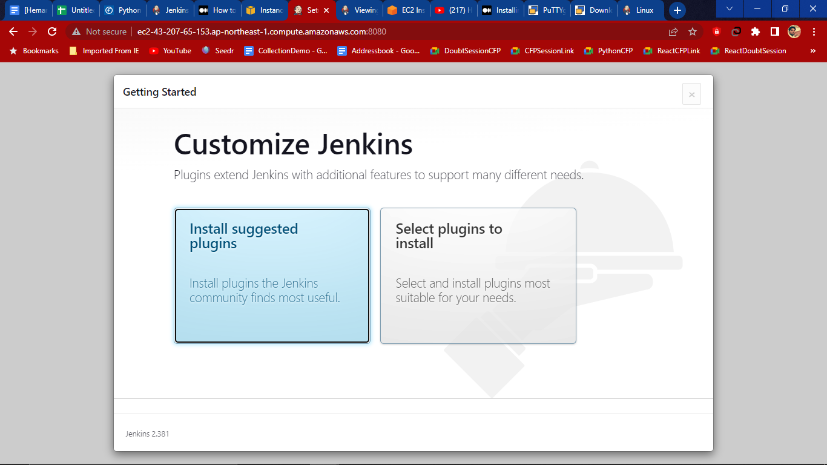

18. Now create a user name password (pass Hemant@10) and hit save and continue.

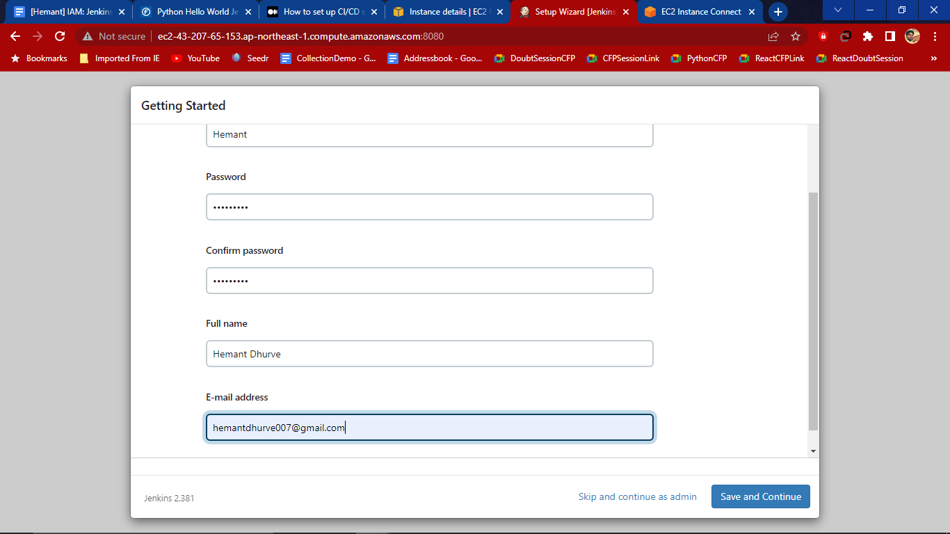

19. We get a jerkins url by default the click on save and finish

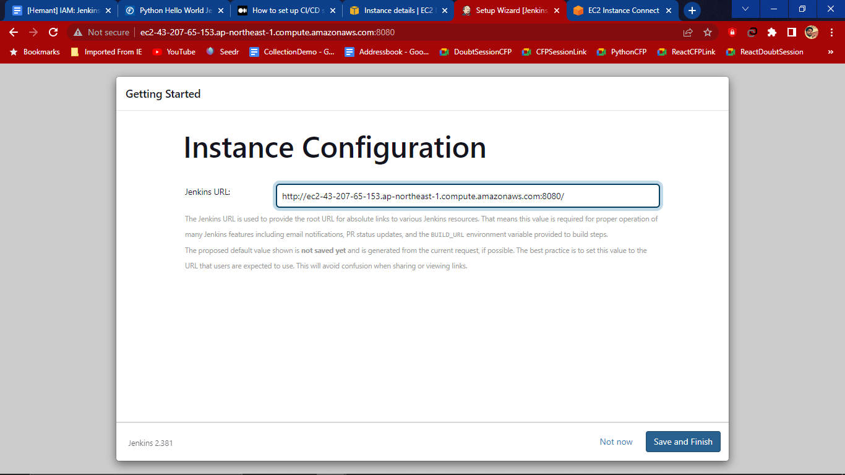

Here we get the jerkins dashboard with version 2.381

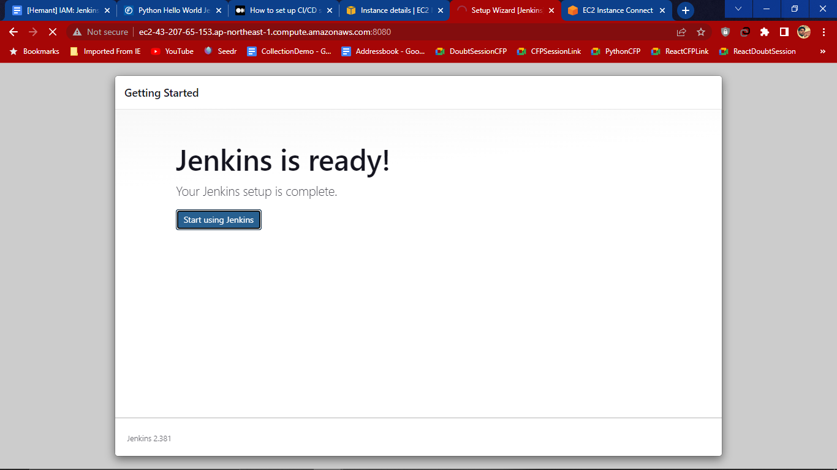

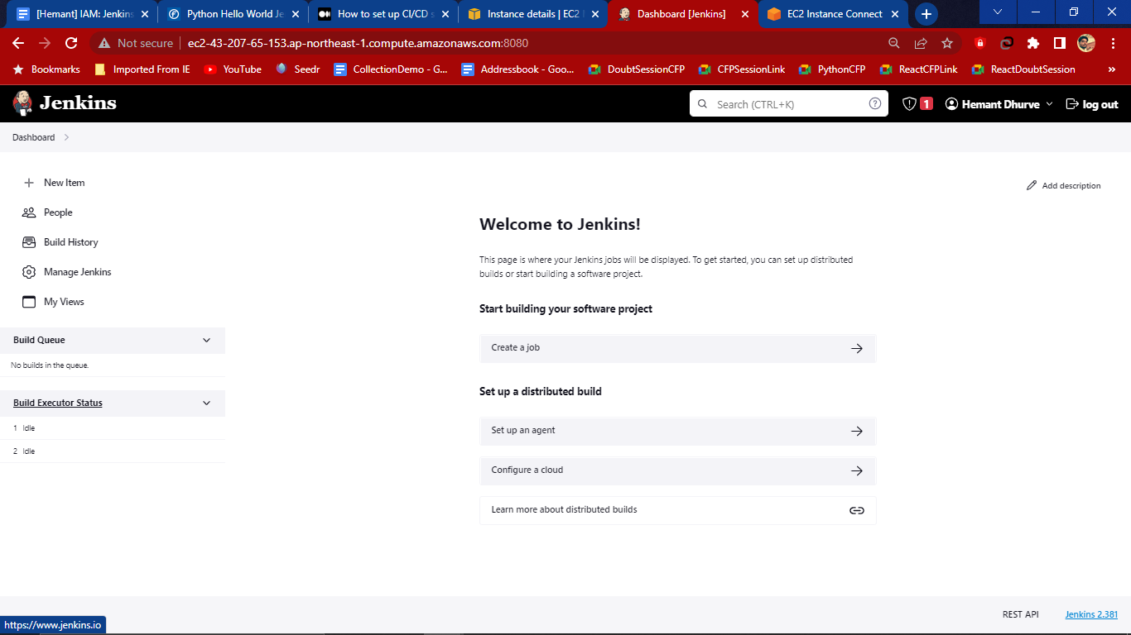

20. Click on New Items to add the items for the very First time and enter the name

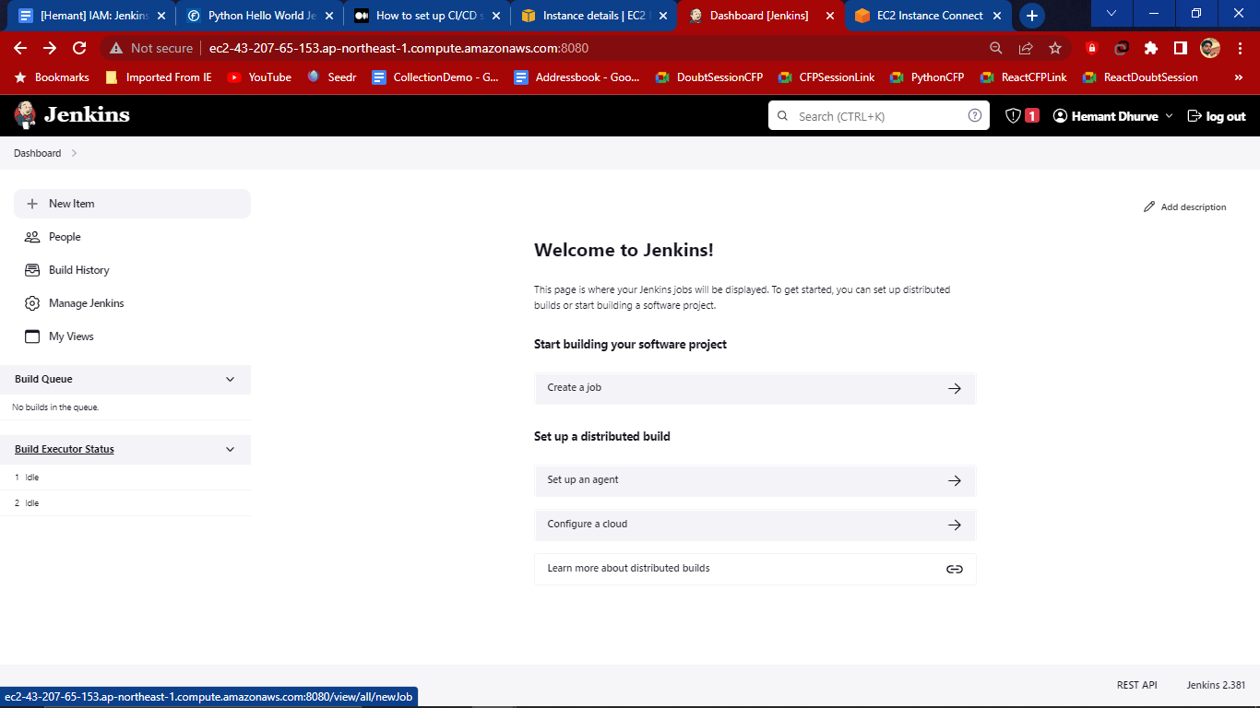

21. Give the name (any) and select the pipeline and then hit ok.

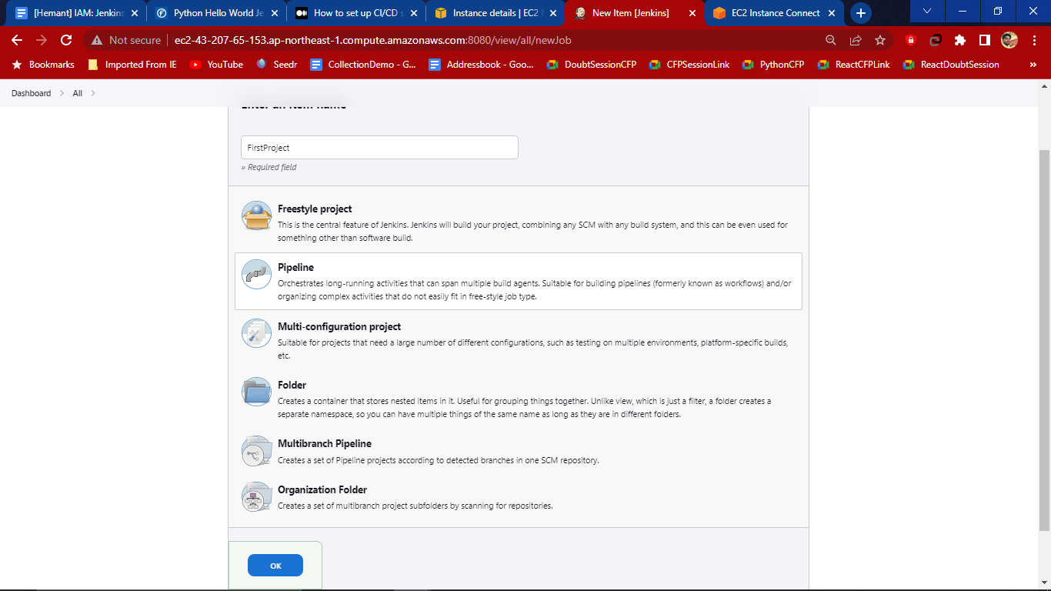

# 

# **Host a python hello world on Jenkins?**

1. In the jenkins UI/Dashboard click on New items and then select pipeline 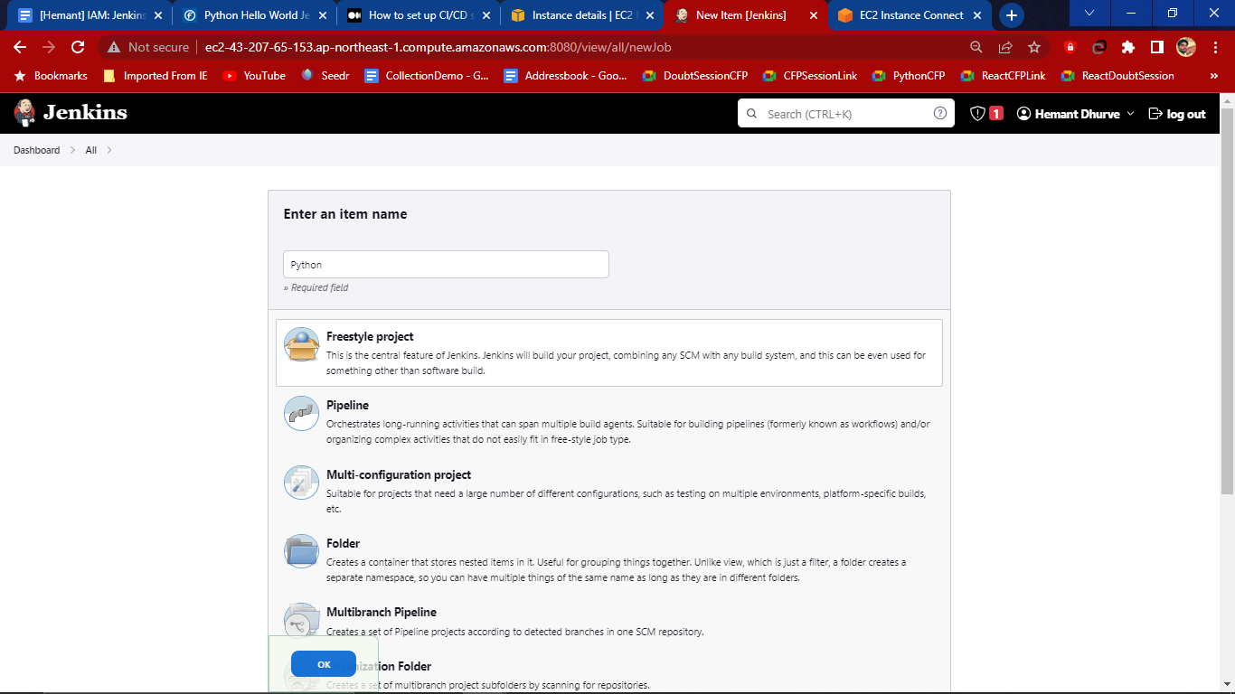
2. In the Configure select Pipeline tag and under script write a hello world program

pipeline { agent { label 'master' } stages { stage('build') { steps { echo "Hello World!" } } } } or try to using dropdown there is hello program 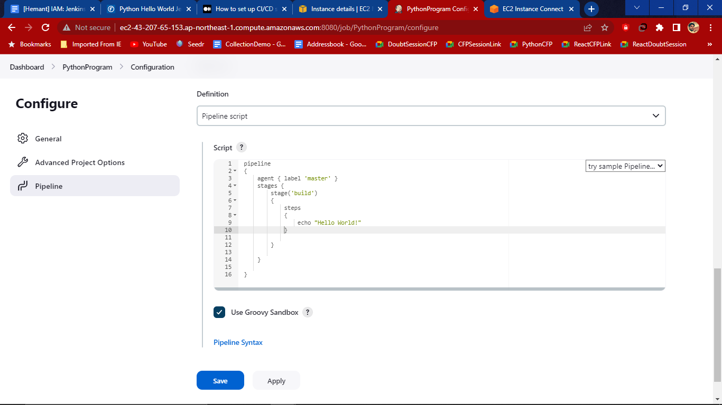

Then apply and save and now build the program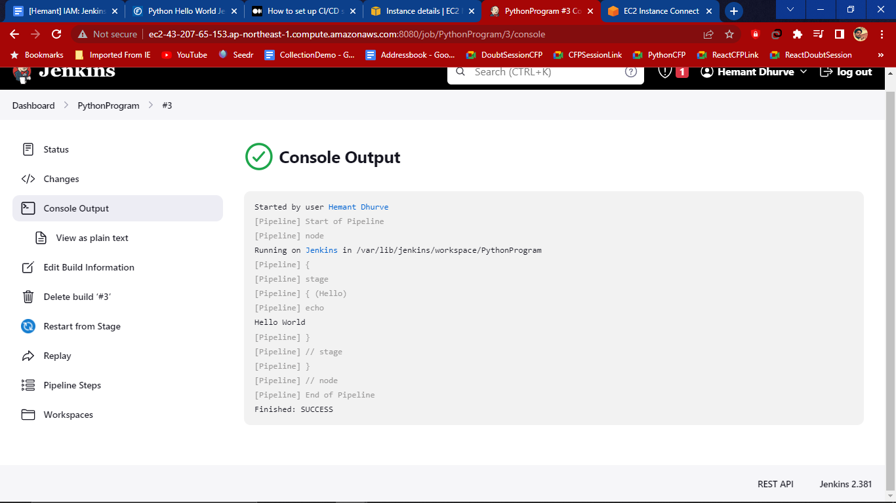

Here successfully program run on jenkins

# **Deploy a python web application via github+jenkins+Elastic Beanstalk**

1. Create User and give programmatic access and hit Next

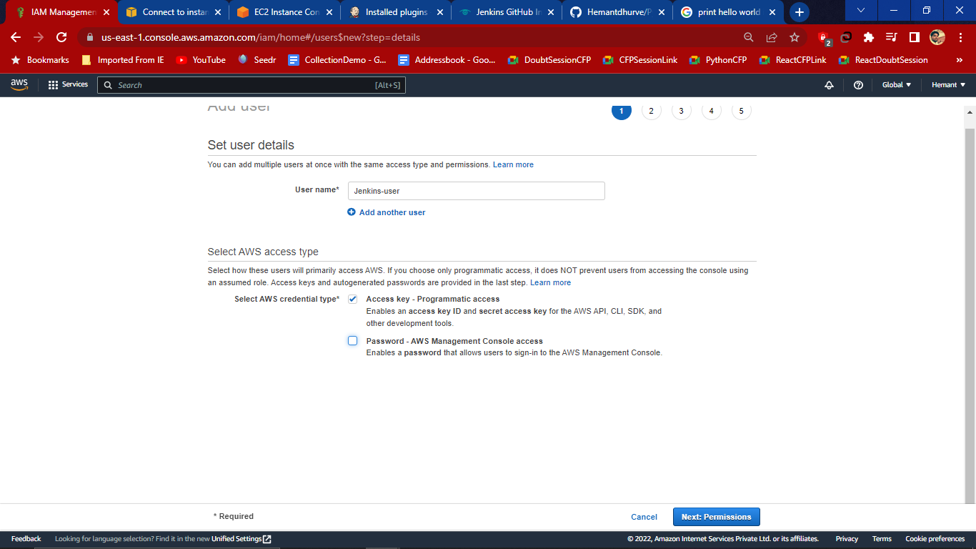

1. Now attache existing policies directly as AdmministratorAccess-AWSElasticBeanstalk which provides full access

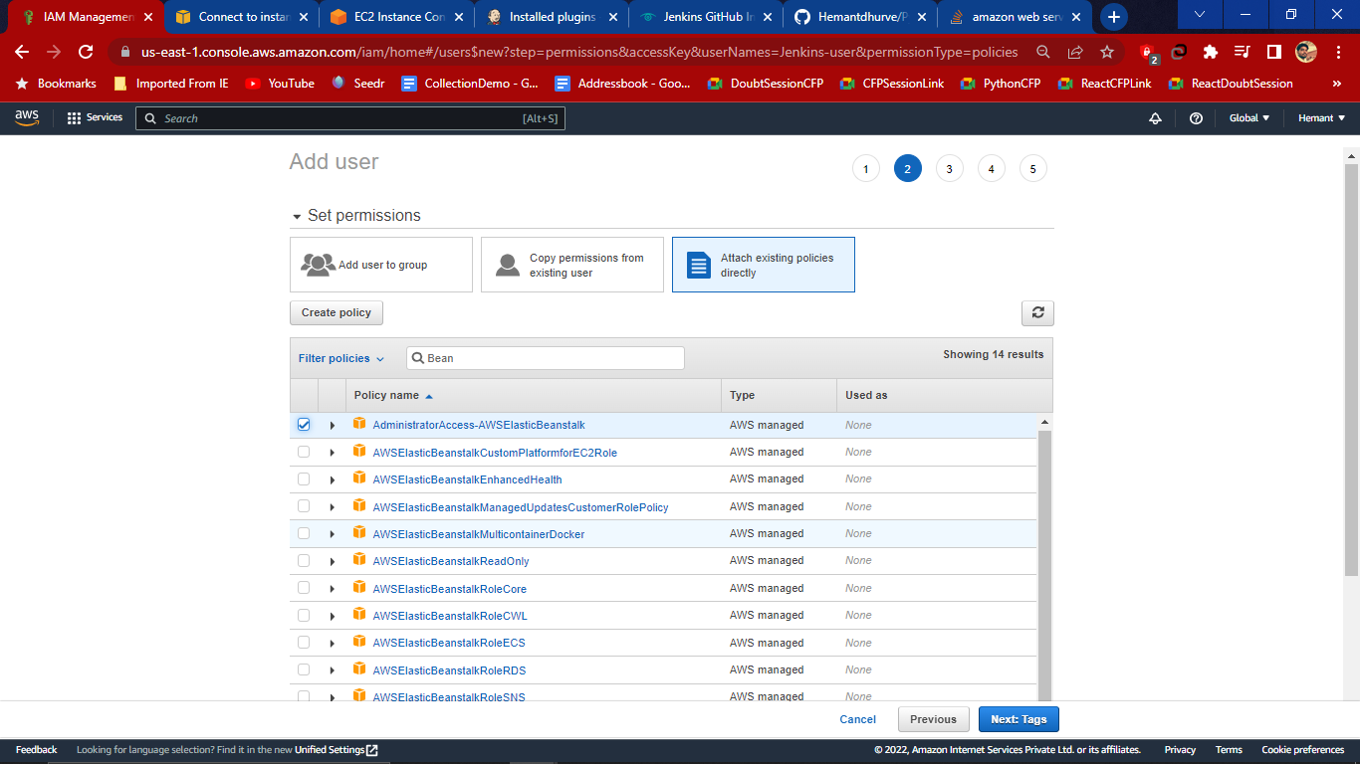

1. Create user

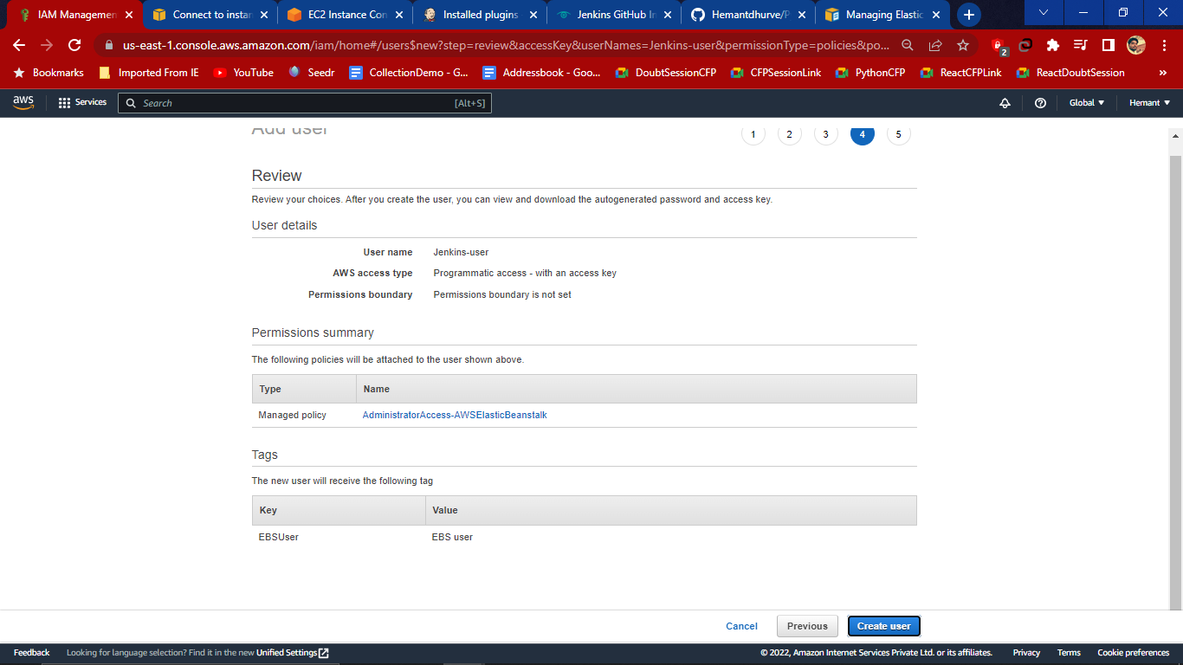

1. Now Open Beanstalk dashboard,

In the Dashboard search for the Elastic Beanstalk then click on Create Application

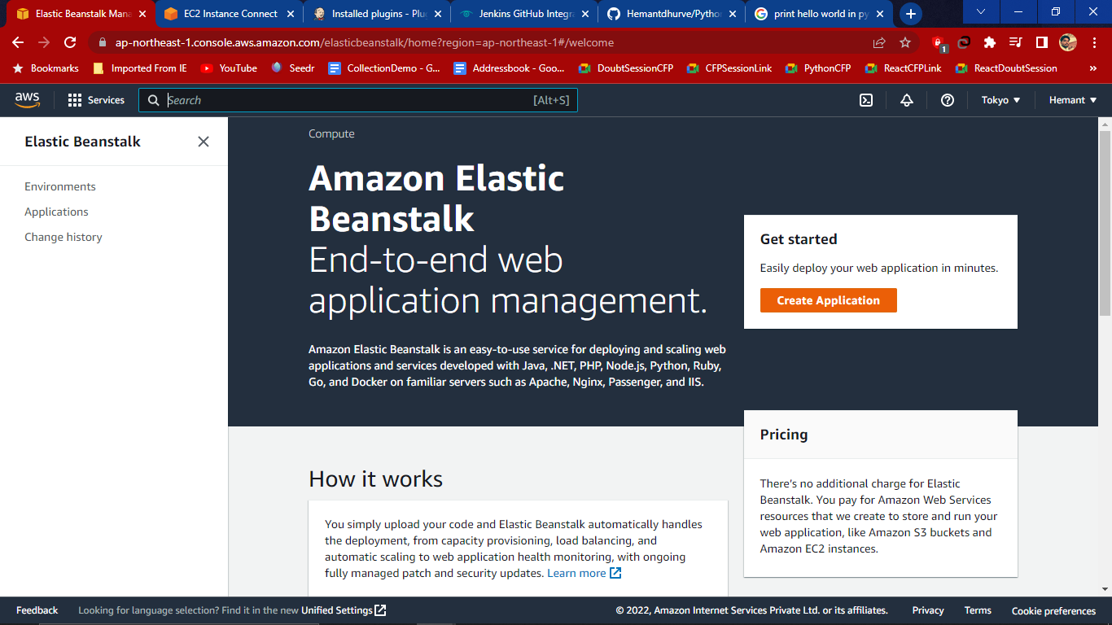

1. In Create a web app Give any meaningful application name

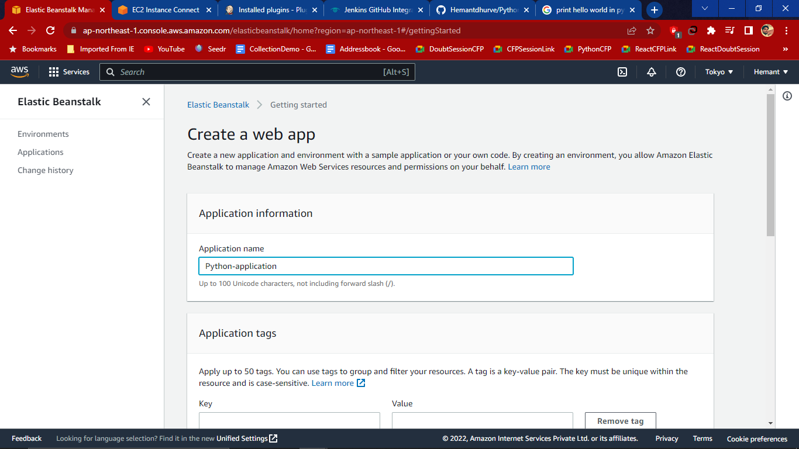

1. Then add tag and select Platform as python

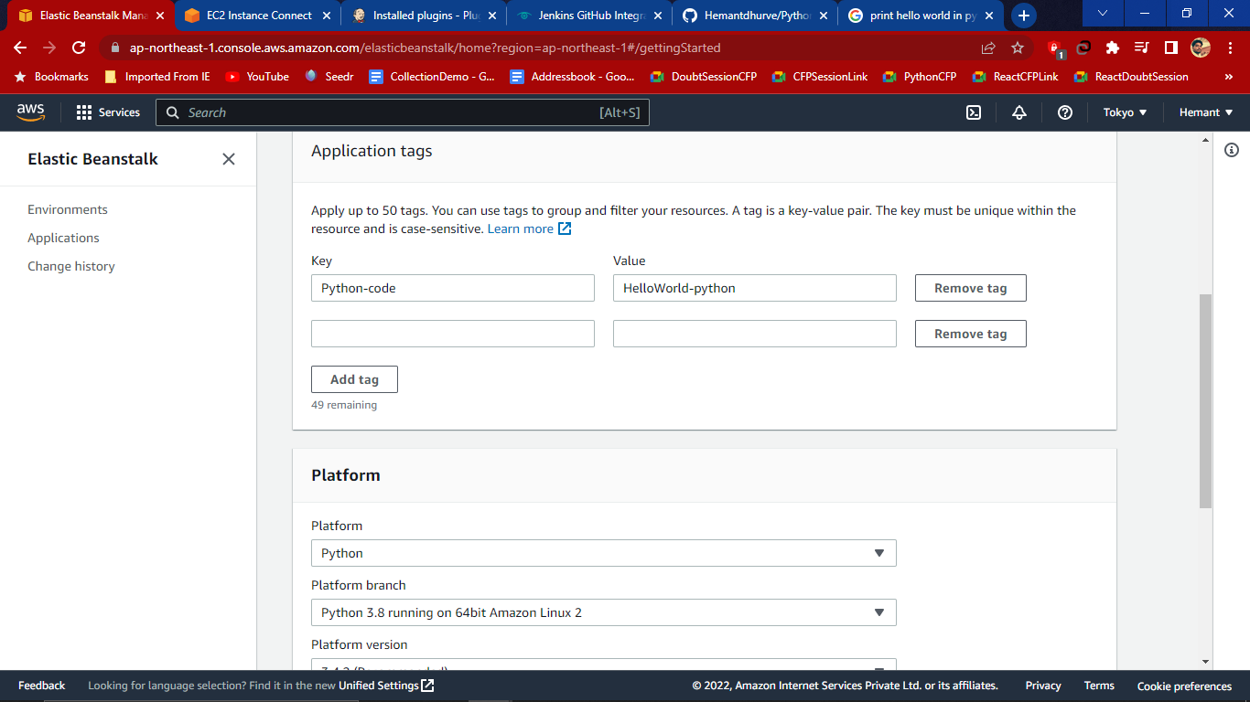

1. Choose Application code as sample and then click on configure more options

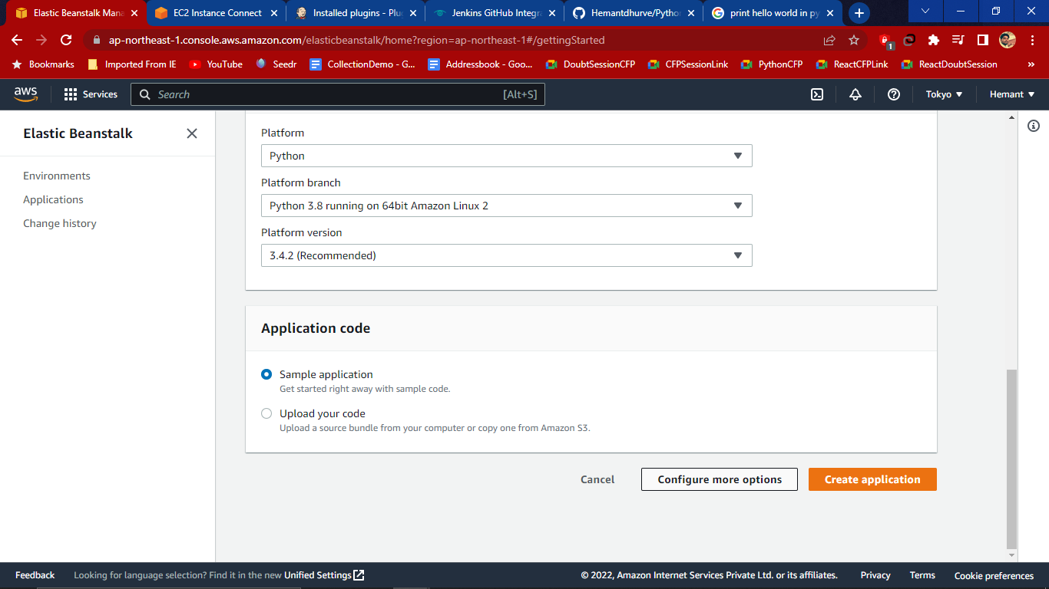

1. Configuring pythonapplication env

In presets select High availability and platform linux

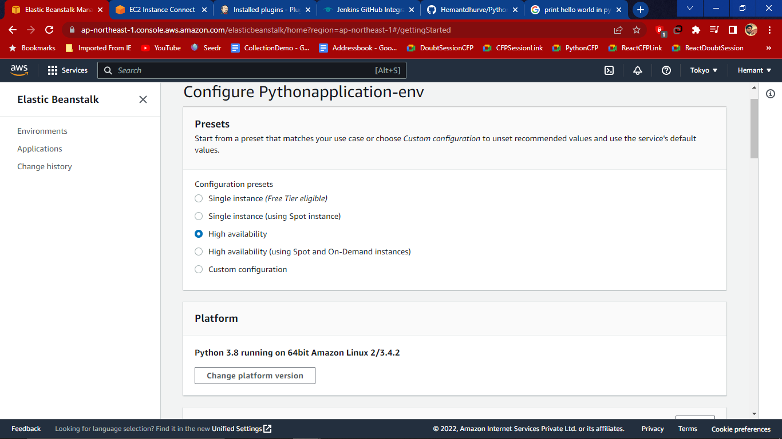

1. Go the the capacity and hit Edit. To modify capacity select Environment type Single Instance with Instances min and max

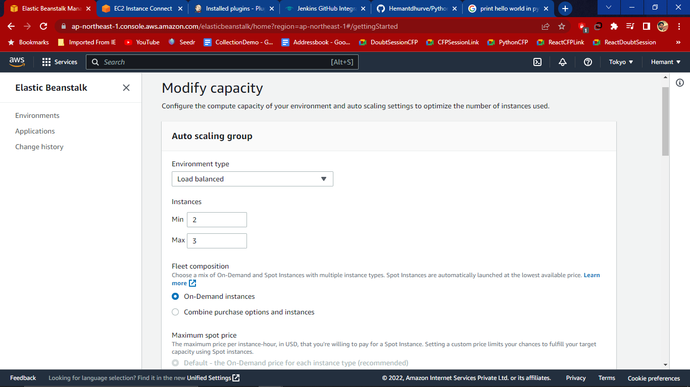

1. Choose Instance type- t2.micro , t2.small

Availability Zones- Any

Placement- All availability Zones

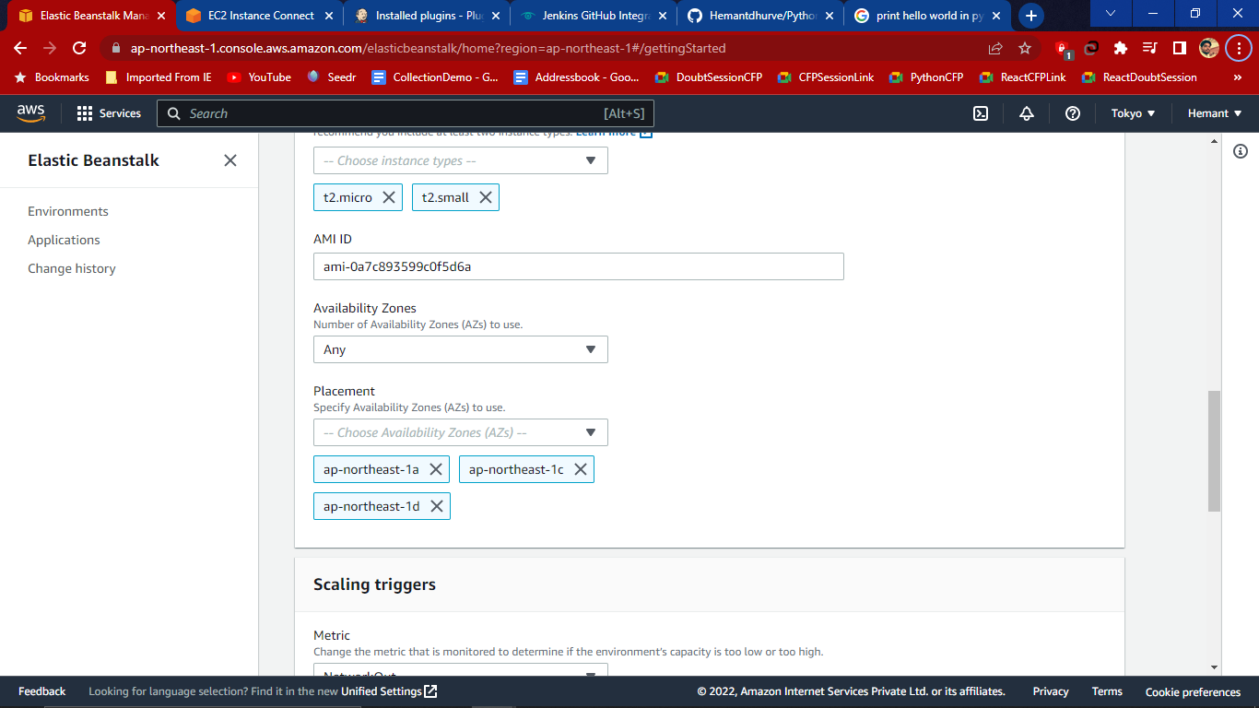

1. In Scaling triggers choose

Metrics- CPUUtilization

Statistic-Average

Unit-Percent

Upper Threshold- 75

LowerThreshold- 20 and then Save

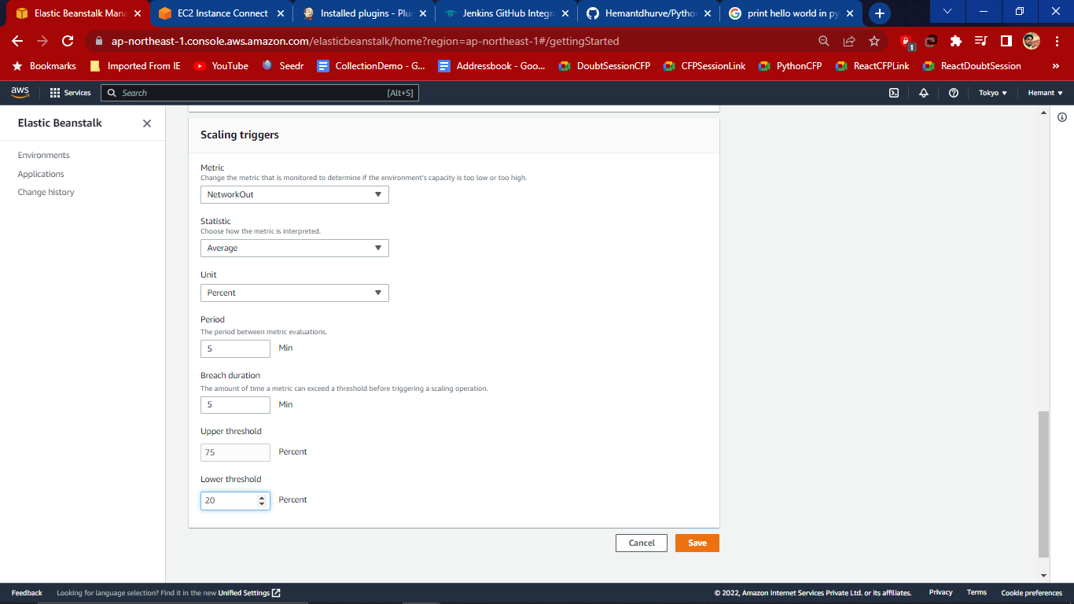

1. Then Edit Rolling Update and Modify

Deployment policy- All at once

Batch Size- fixed

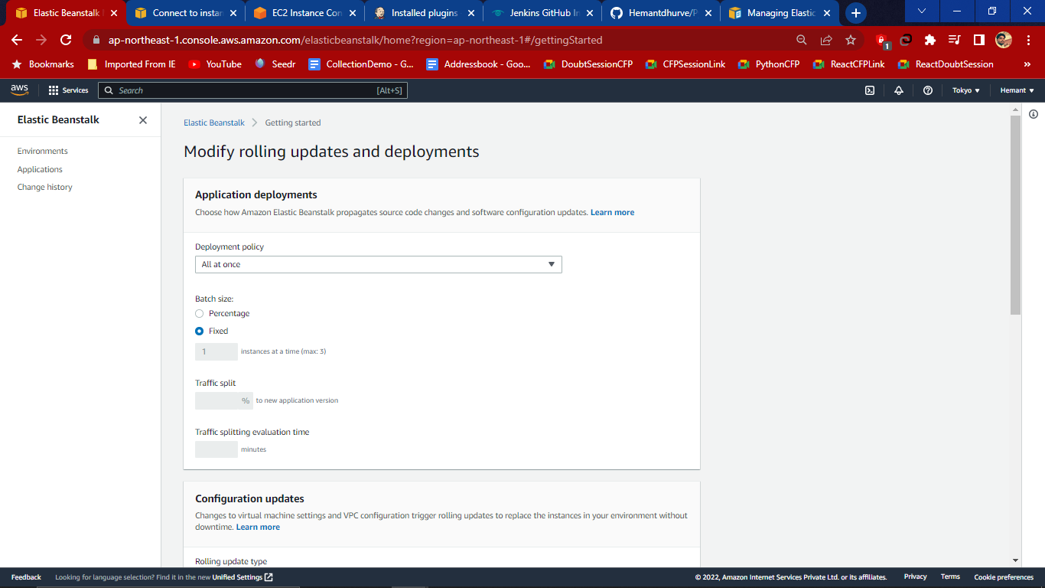

1. Configuration Updates change from Disable to Rolling based on Time then enter Save.

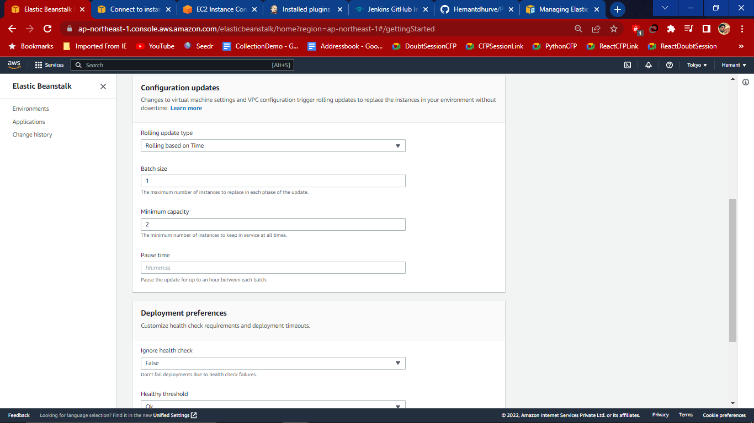

1. Then from Env page Click on create App. Here App Environment is starting

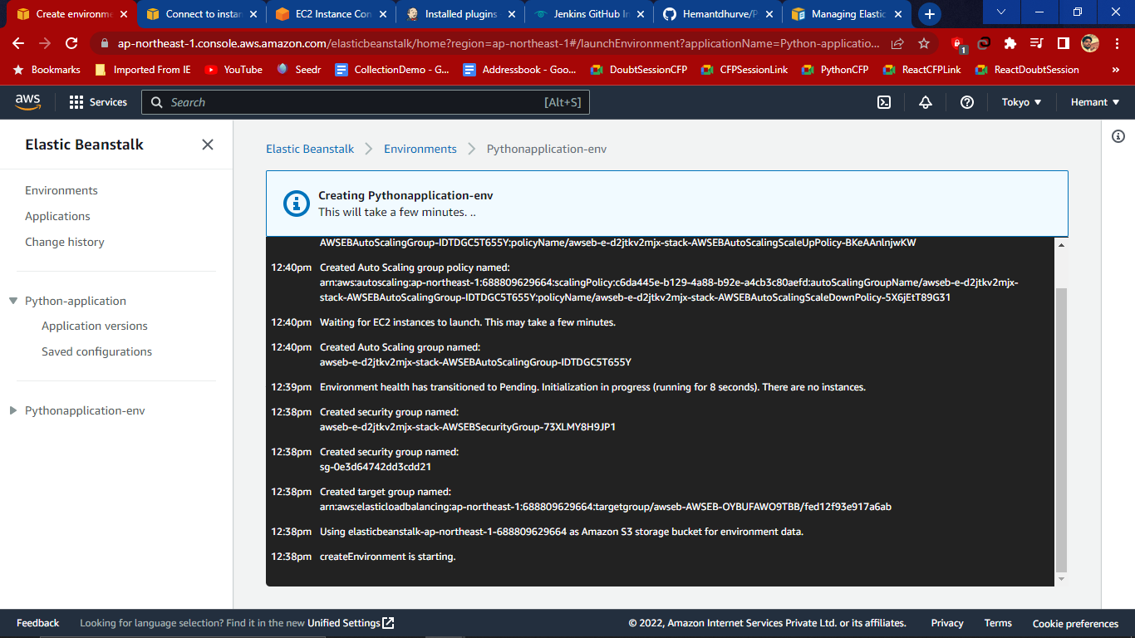

1. Then go to the EC2 instance where we will get the Instance of beanstalk that we have just created

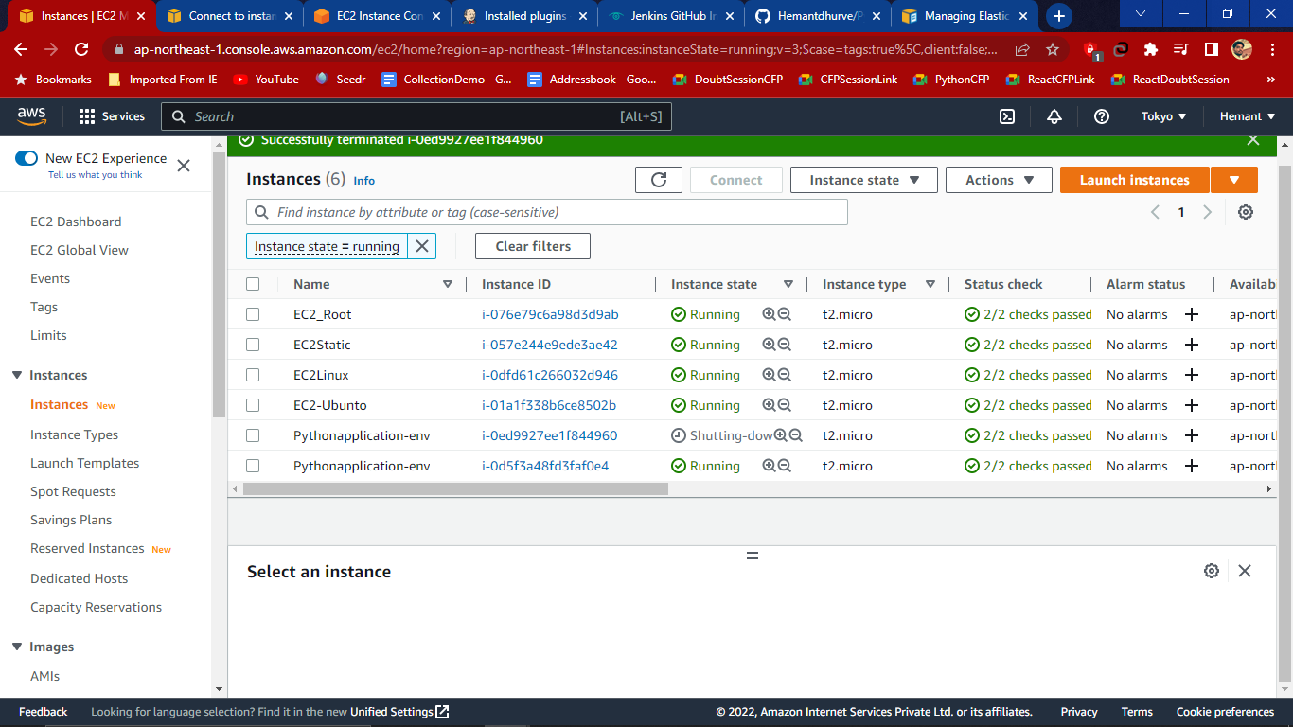

1. Then login to the jerkins page

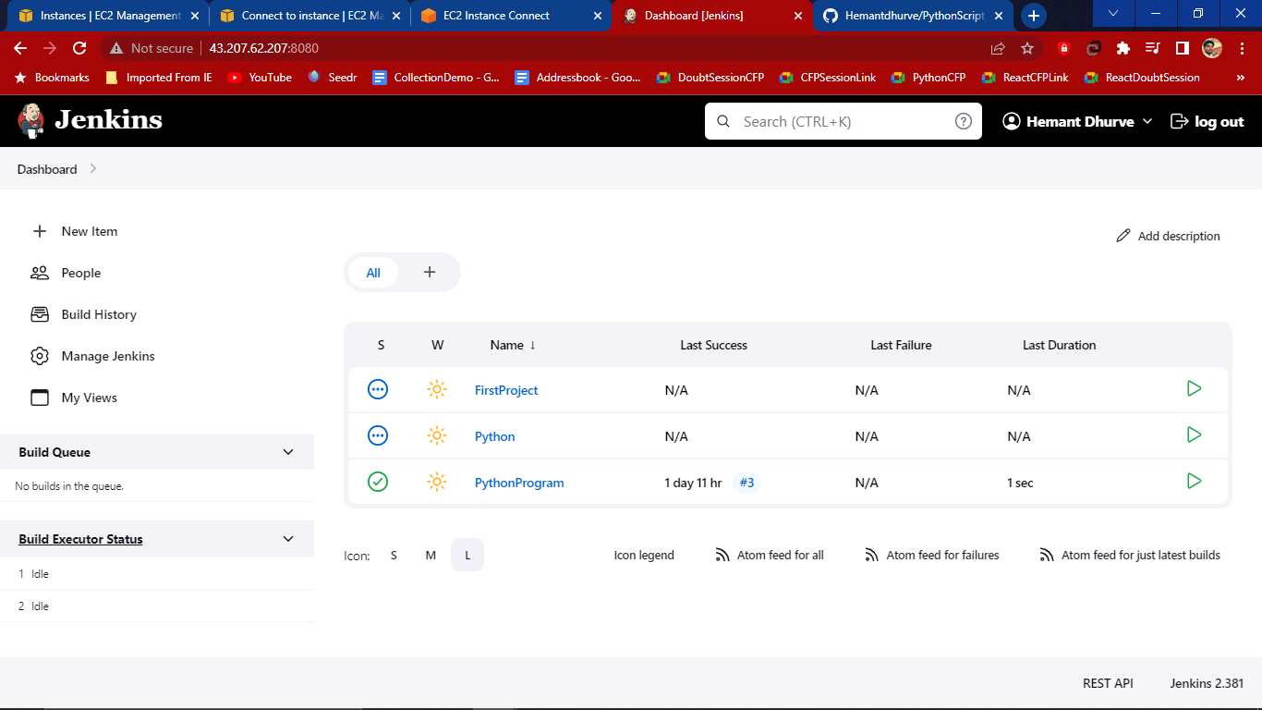

1. Search for the plugins to install ie. GitHub Plugins ,pipeline: Github groovy library. Source code, and git Parameters
2. Then check the health and platform status if it is ok or not in beanstalk dashboard

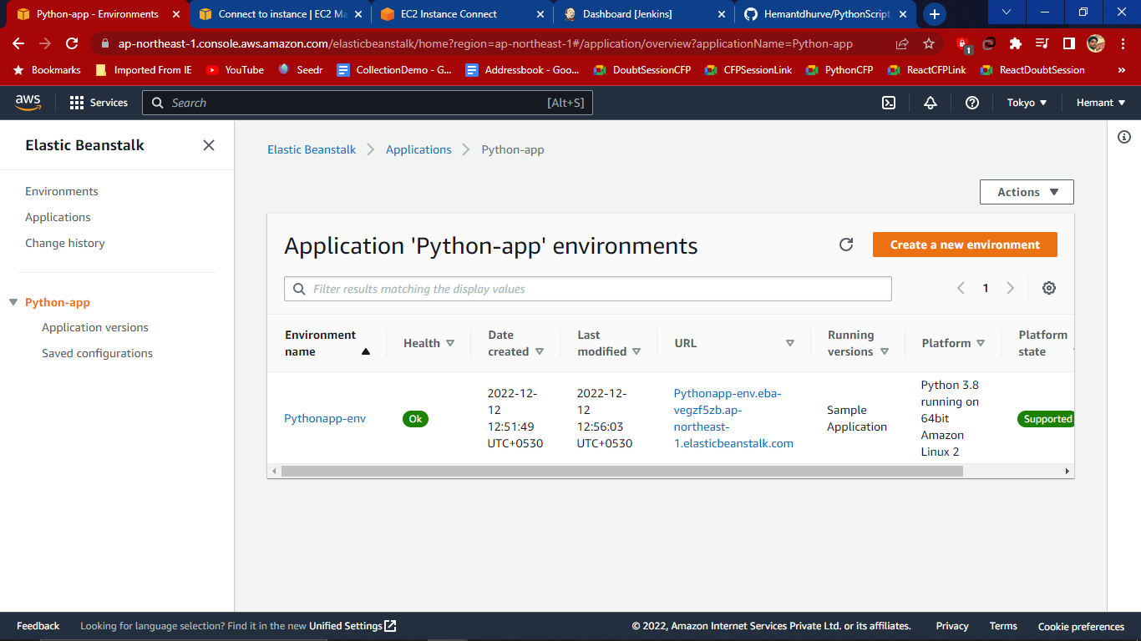

1. Then download AWS beanstalk from the Available Jerkins

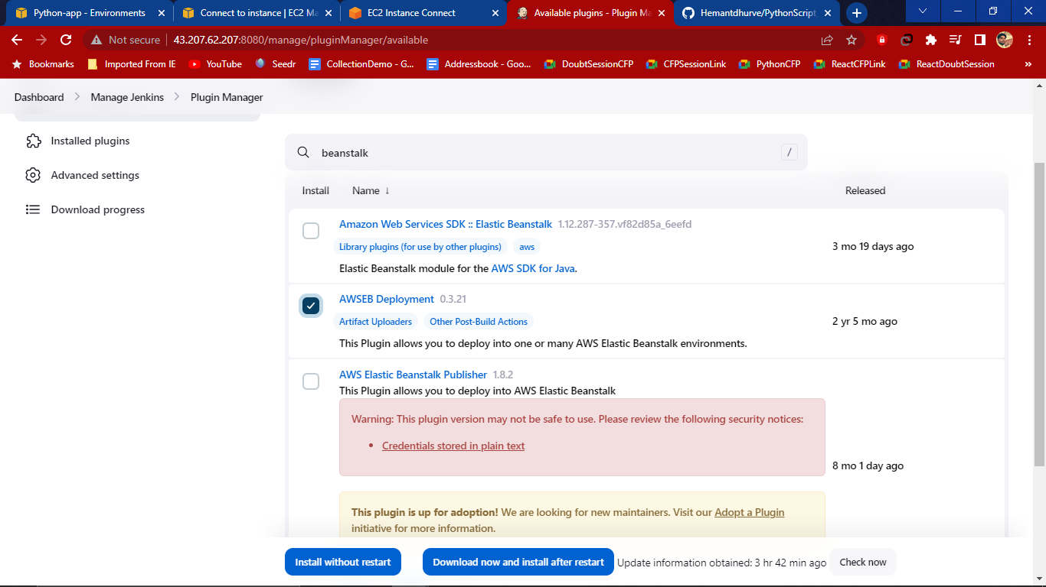

1. Now to link with the gihub use the command - **ssh-keygen** and enter file name where we want to save **i.e jenkins**

Then pass any phrase when it matches randomart image is generated

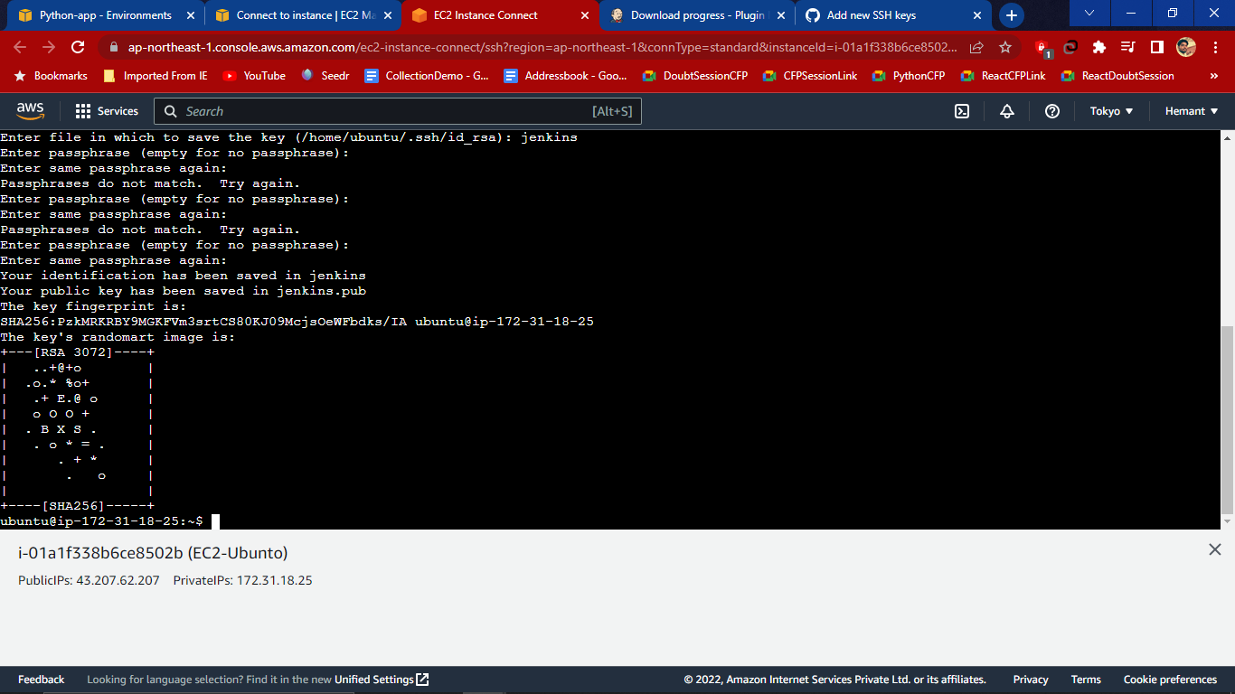

1. Then use - **cat jenkins.pub** command to key the generated key which start from ssh-rsa

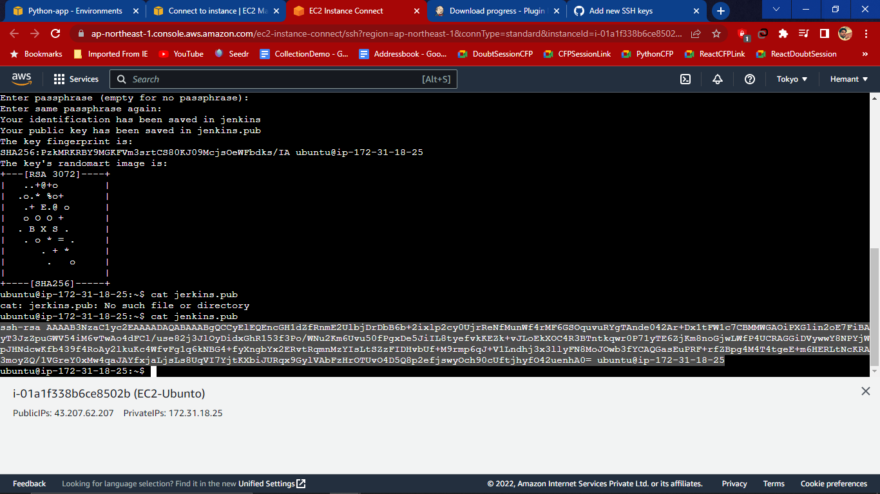

1. Then go to the github and in setting search for the SSH and GPG keys

Give title and key which starts from ssh-rsa which is generated then paste in github key section and ssh key

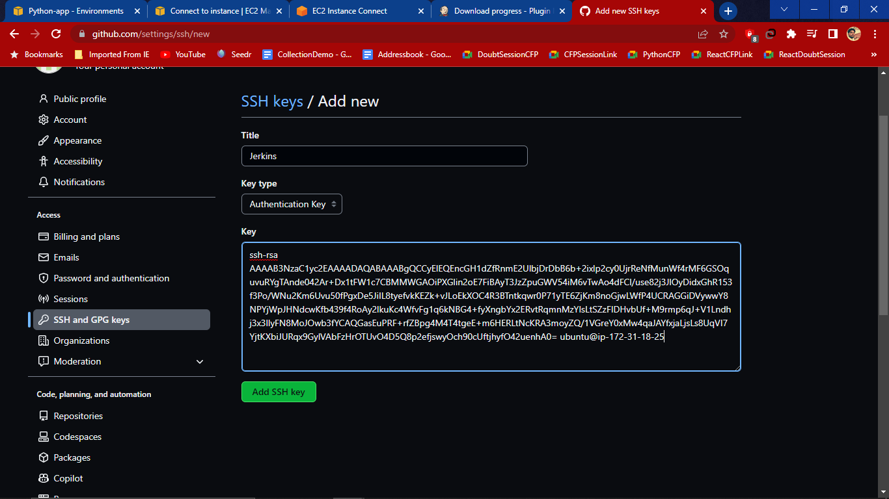

1. After adding we will get the jerkins Authentication key in the github

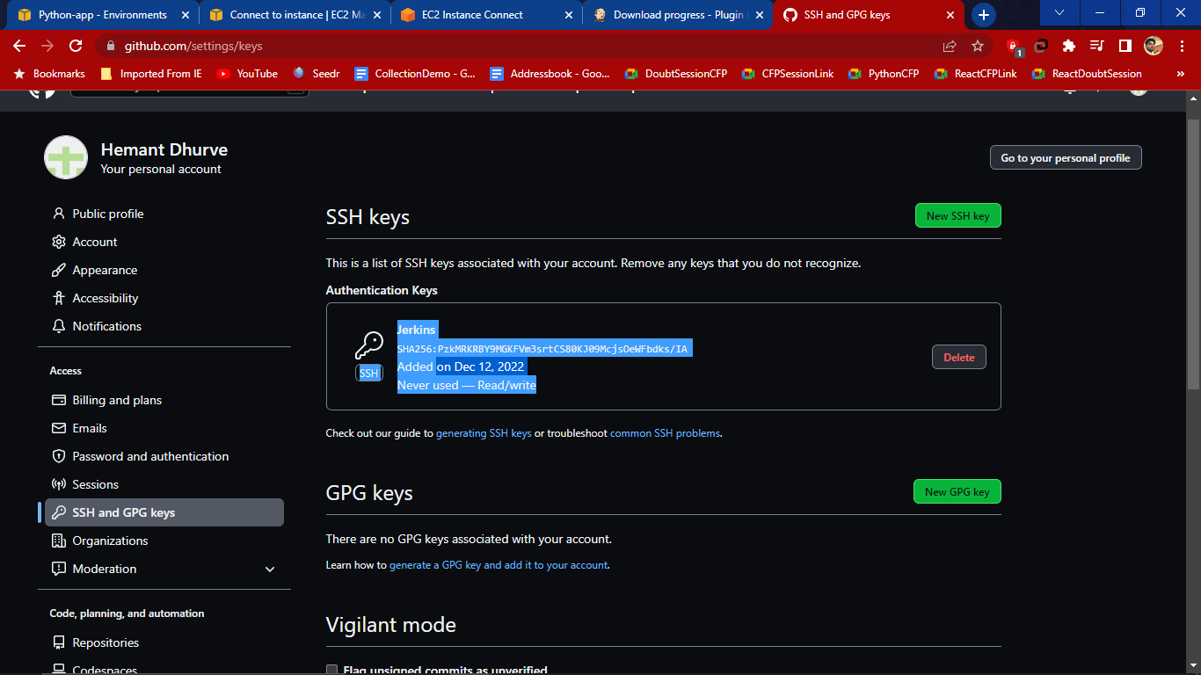

1. Now go to the Jerkins dashboard and click on credentials we get the user

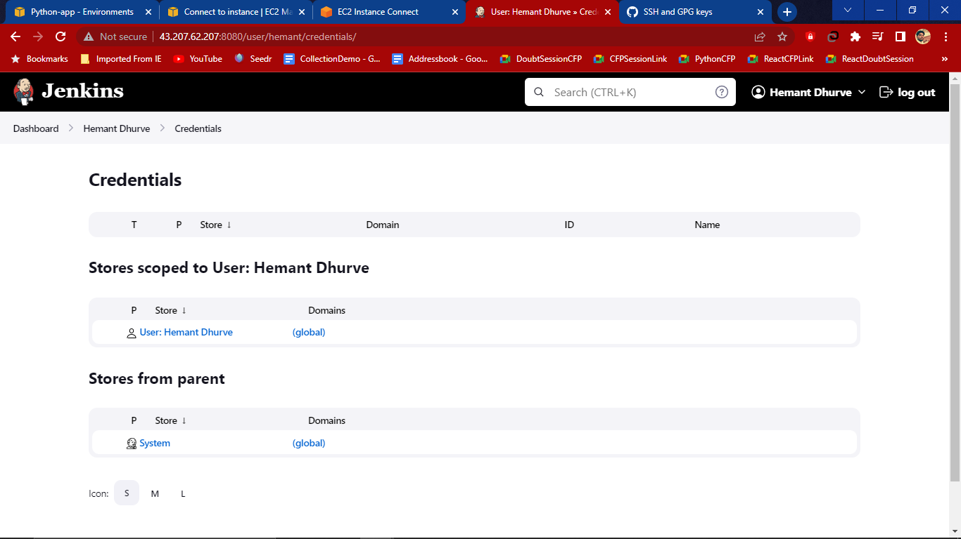

1. Create new item and select freestyle Project with any name

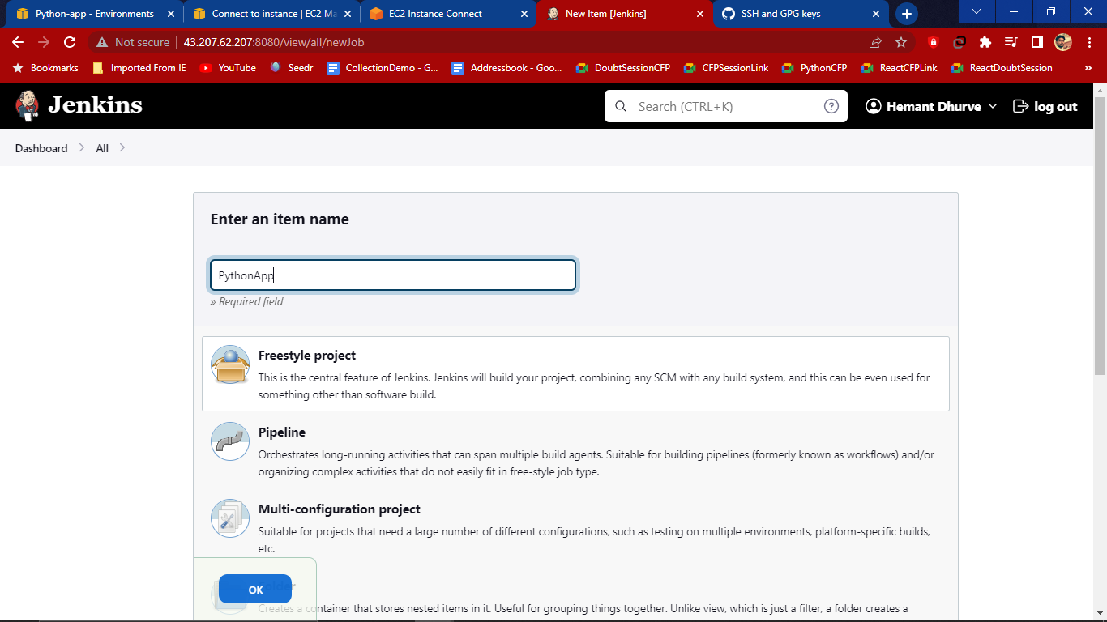

1. In General Tab give Relevant description and check discard old builds max to 7

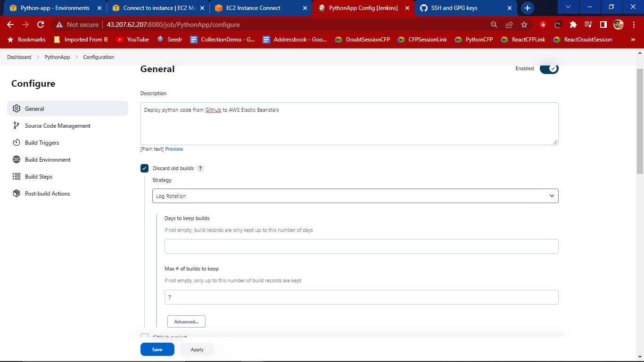

1. Check Github Project and add the project link which we want to project in jenkins

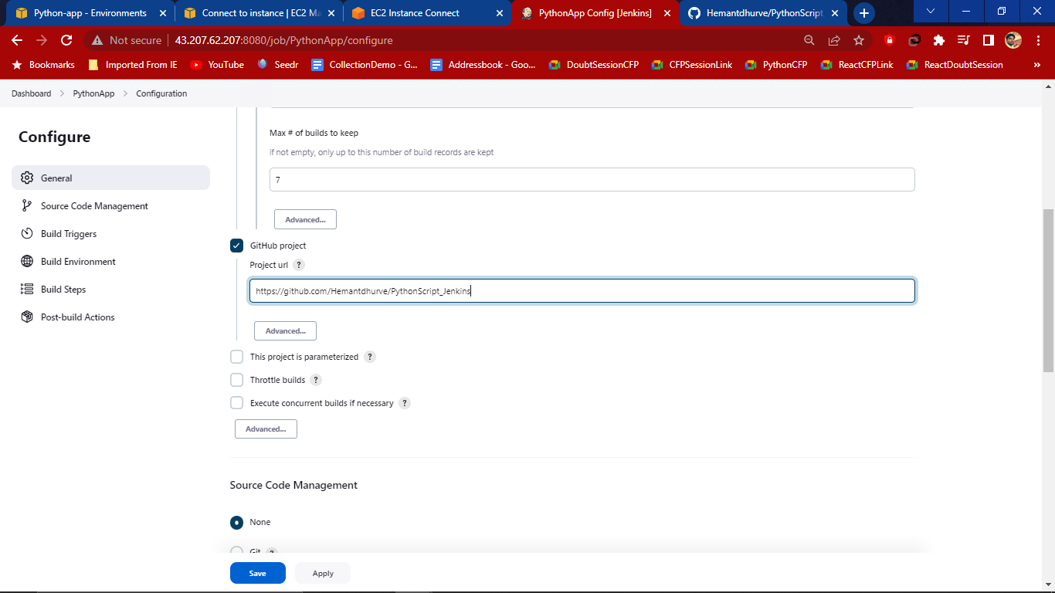

1. Then in source code paste the ssh link from the github

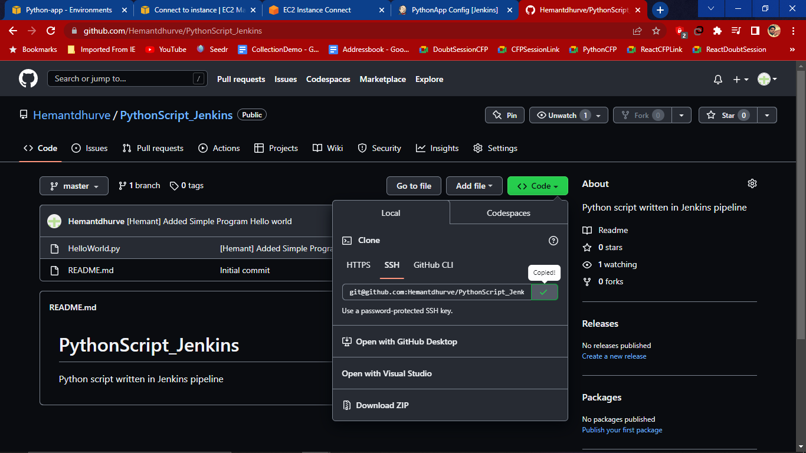

1. Then add Credentials

Domain- global credentials(unresricted)

Kind- SSH username with private key

ID and Description any

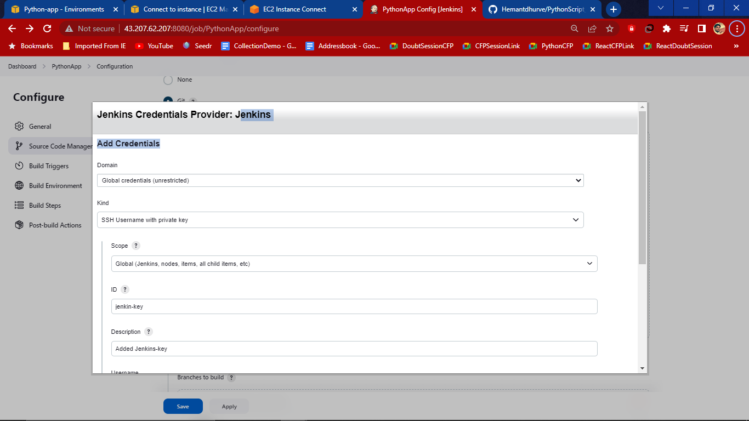

UserName- Hemant (we are working on currently)

Private key -Enter directly. Now to add key click on Add then go to console and use command as - cat jenkins and copy from the beginning to end and paste in the add key section in jerkins

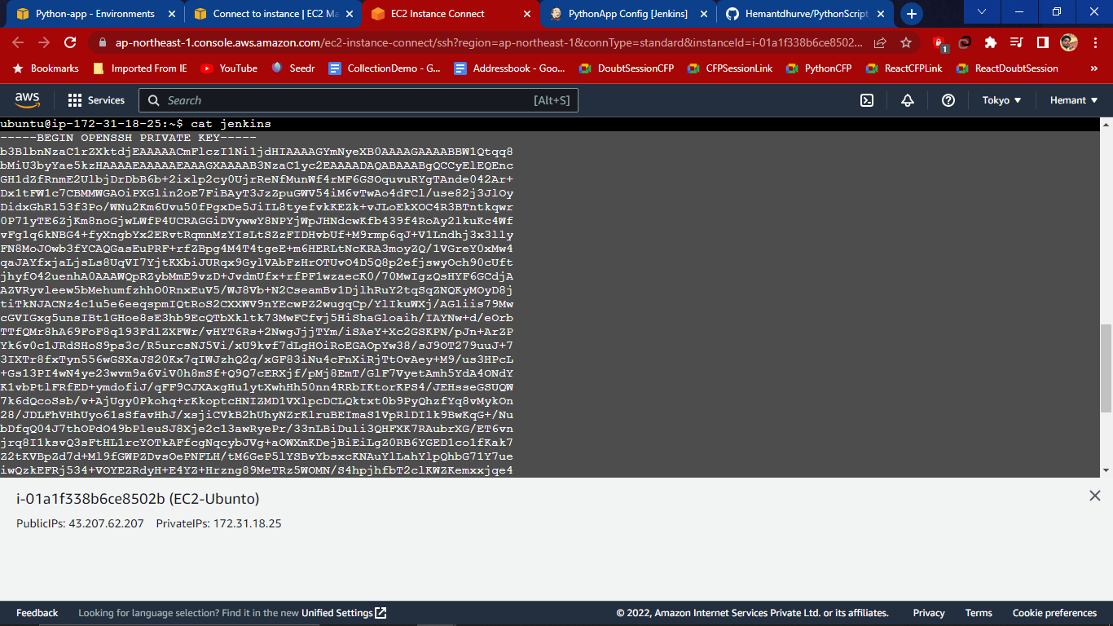

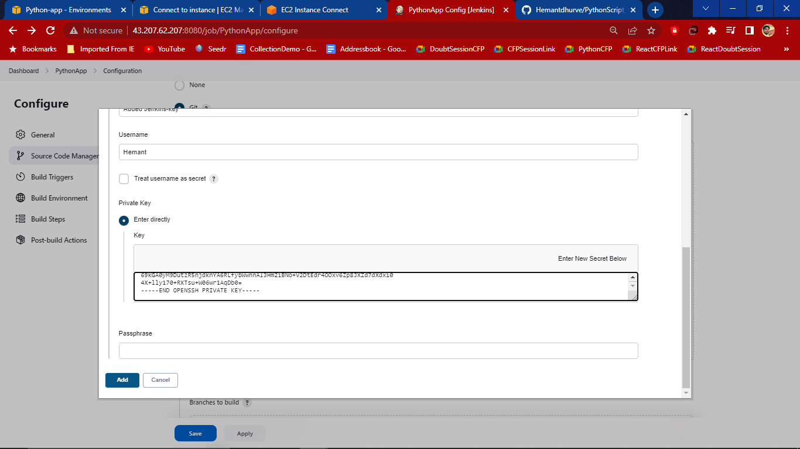

Then add credentials and select branch specifier master or any

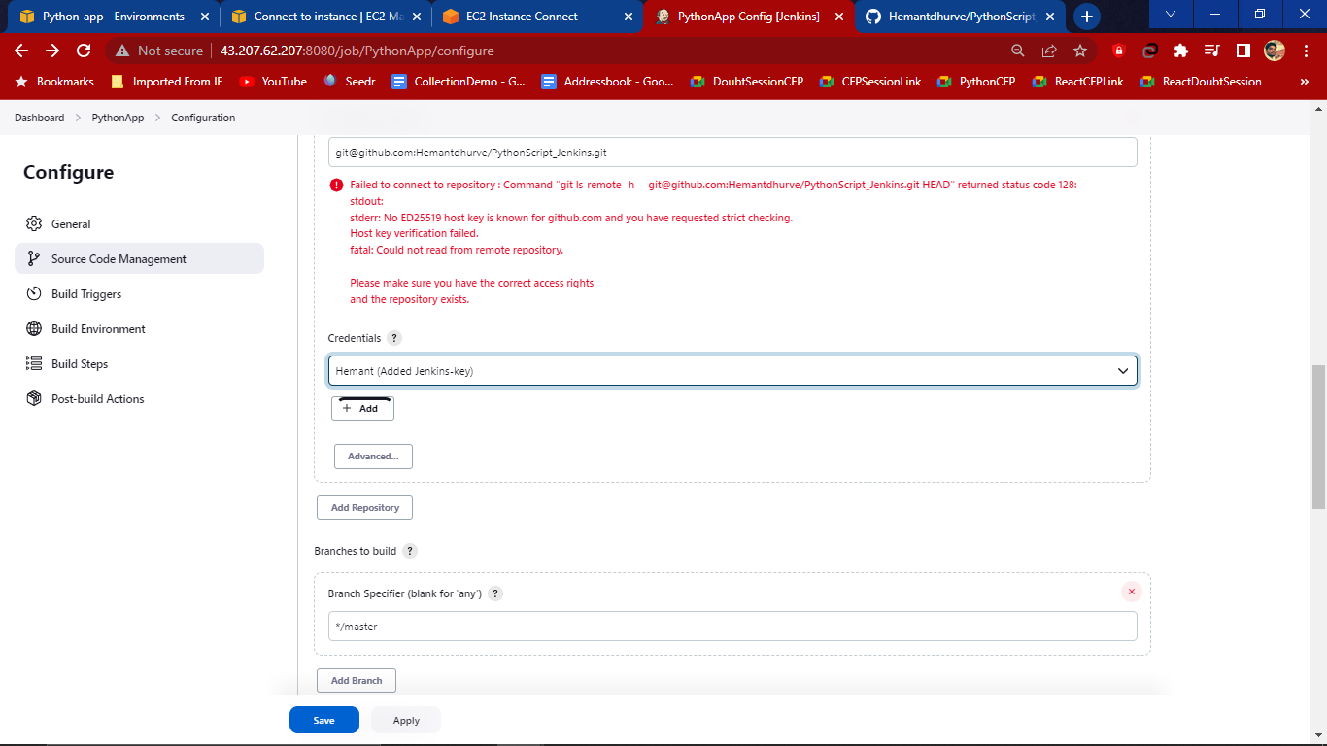

1. In build triggers check Github hook triggers and copy public ip address and paste this ip address in the github webhooks (in setting) **43.207.62.207**

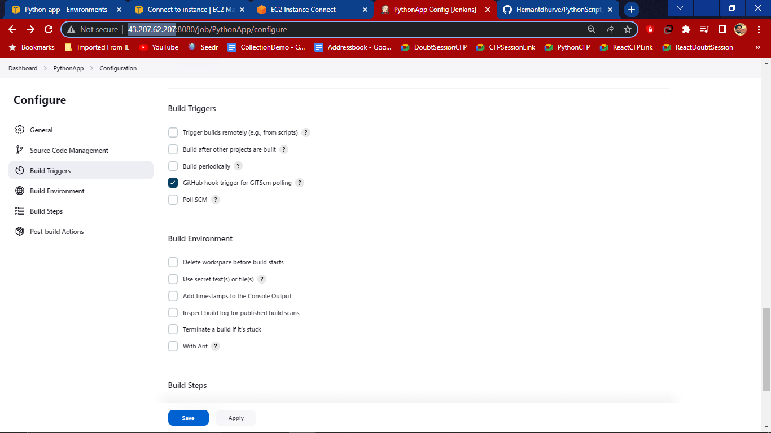

1. Setting-> WebHooks->Add webhooks

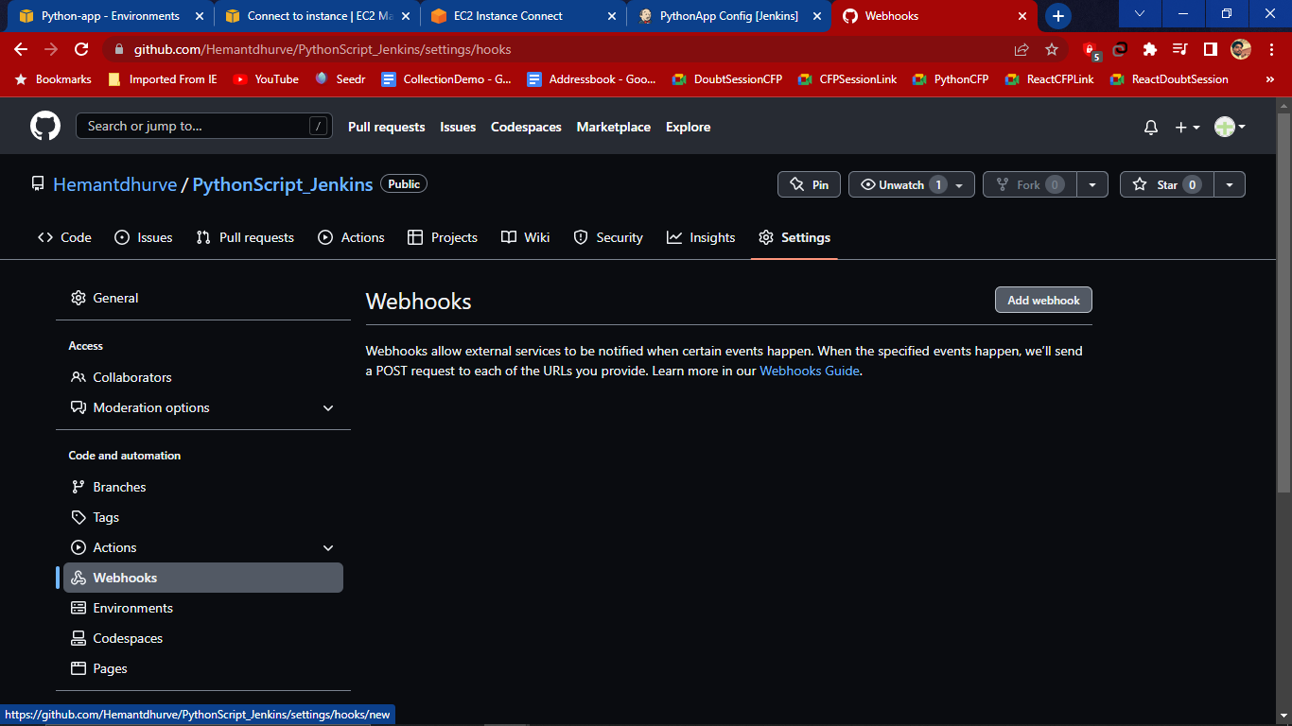

1. In Payload url - **http://43.207.62.207:8080/github-webhook**

Content type- application/json then add webhook

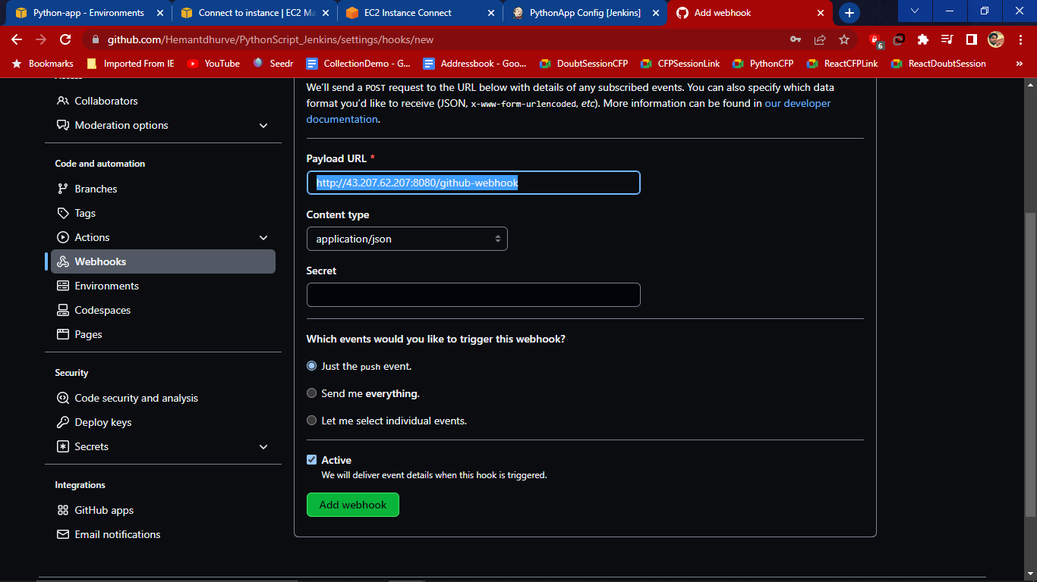

1. We we add the webhook its not successful so that we have go to the build environment and build and select AWS elastic beanstalk(from jenkins)

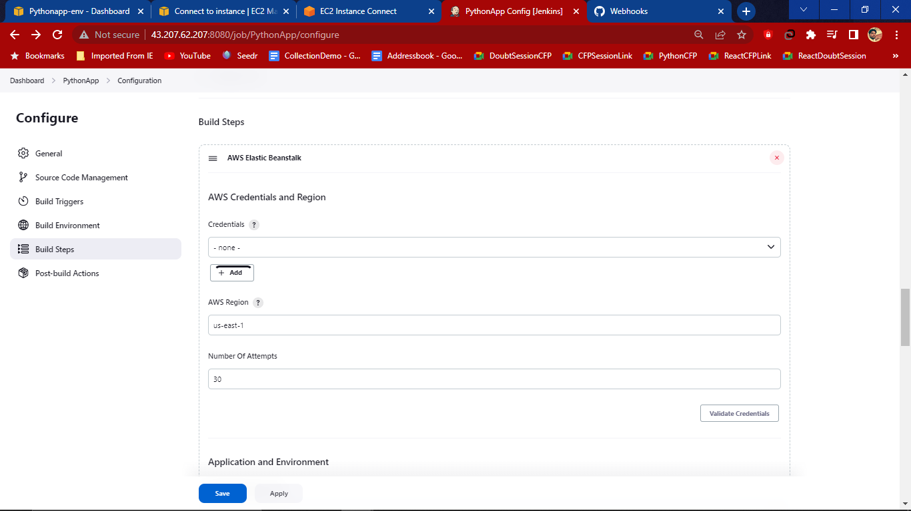

1. Add the credentials

Kind-AWS credentials

ID and Description - any

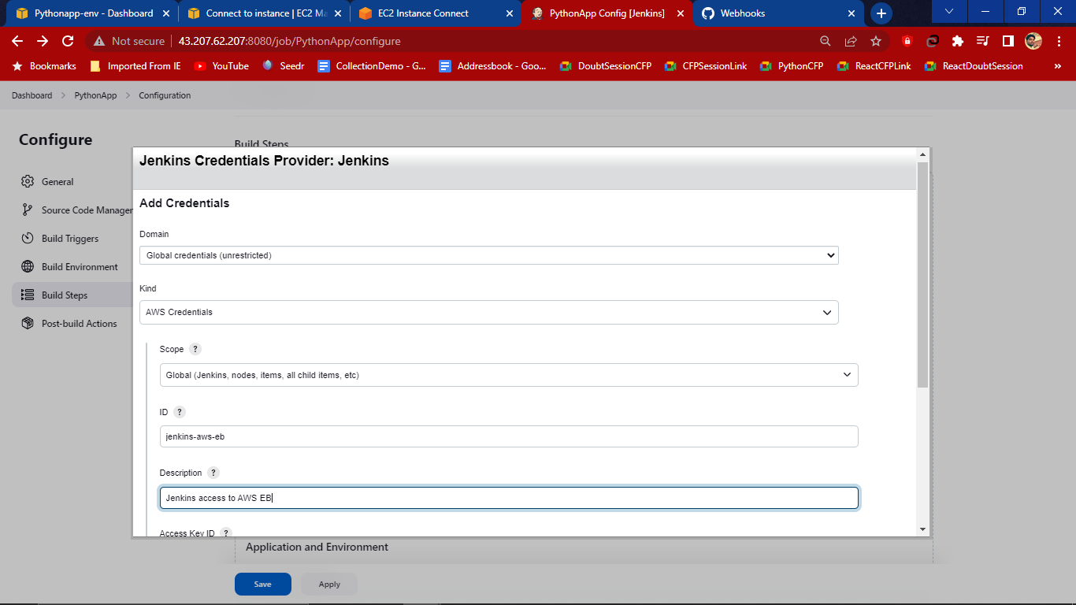

1. Add Access Key Id and access key from the csv file

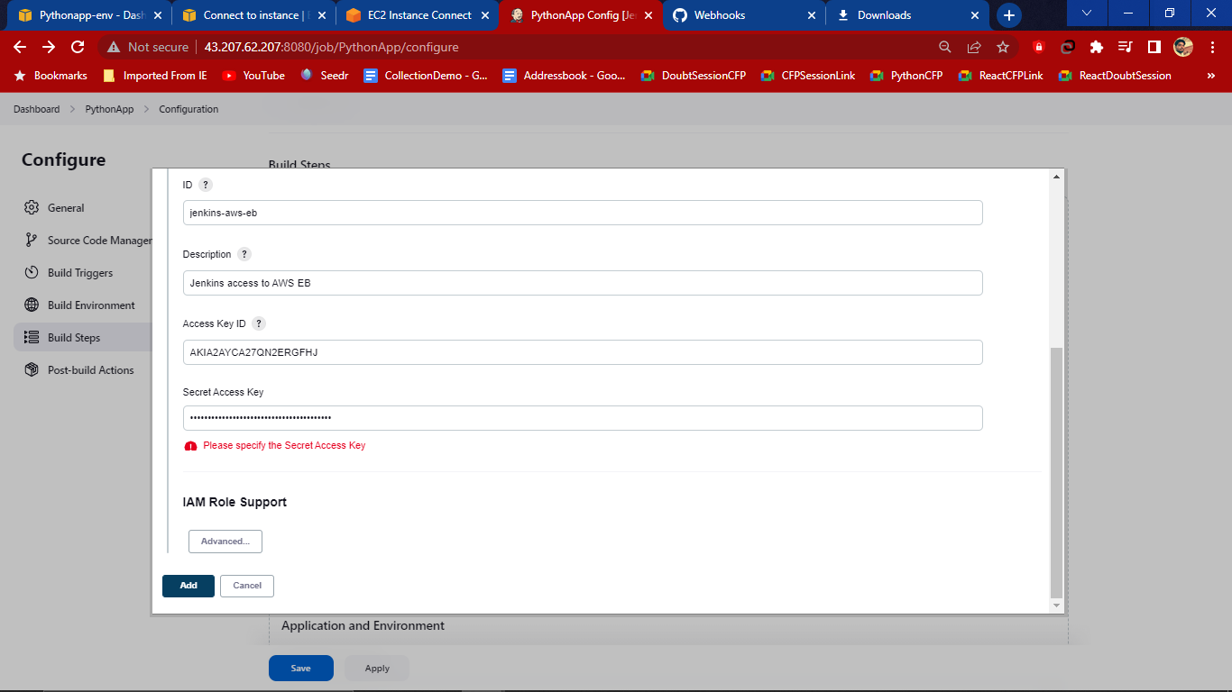

1. Now add credentials and region (see the url of AWS where it is using)

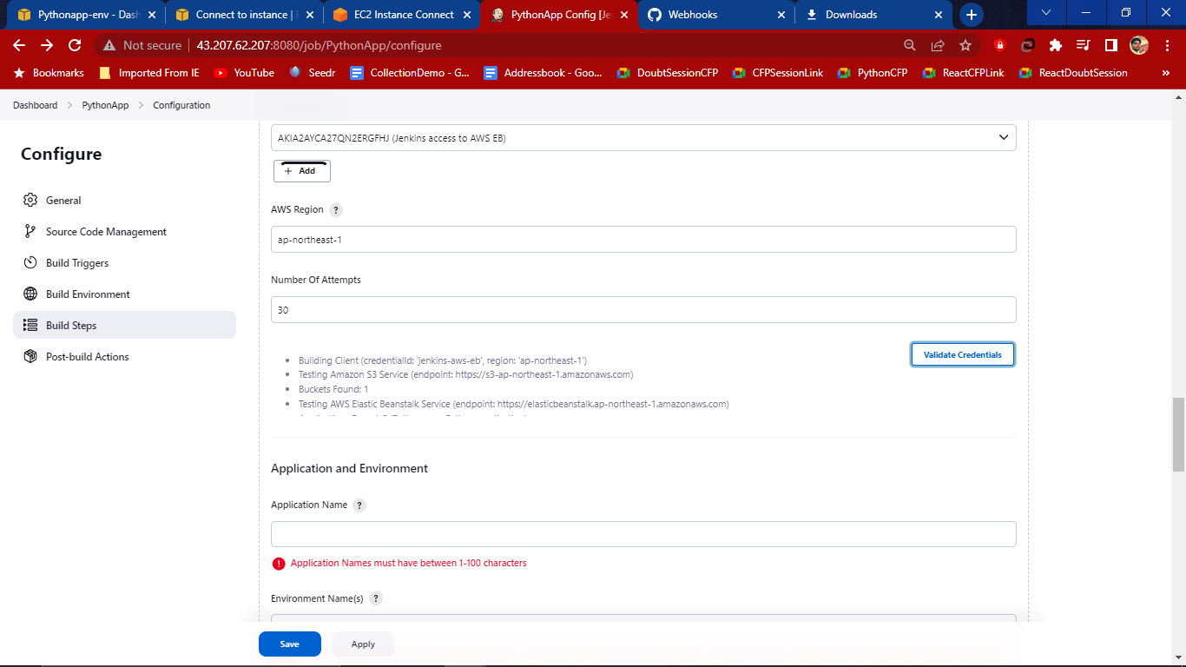

1. Give application name and environment name then validate and in packaging Root object-(.) use

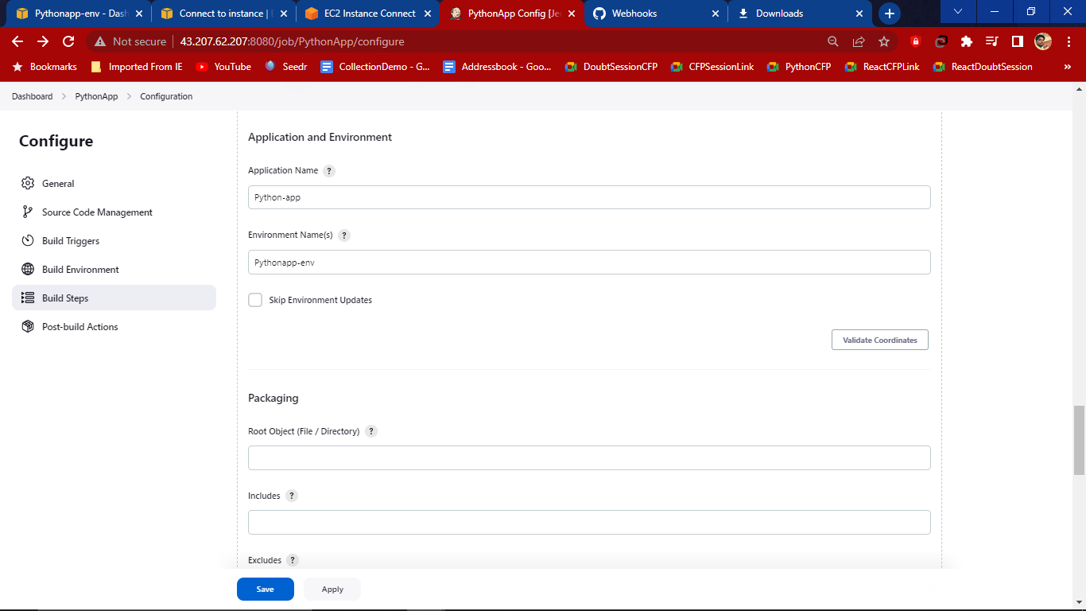

Versioning label format - **jerkins-build-$(BUILD_ID)** and sleep time 30 sec then Apply and save.

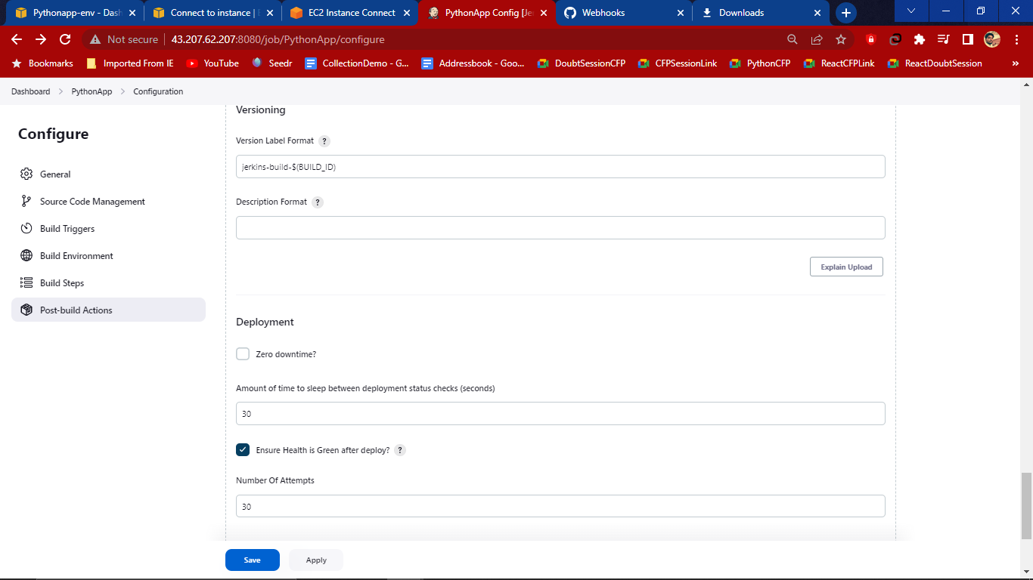

1. Now Go to the dashboard of jerkins and Build the PythonApp by clicking Green button

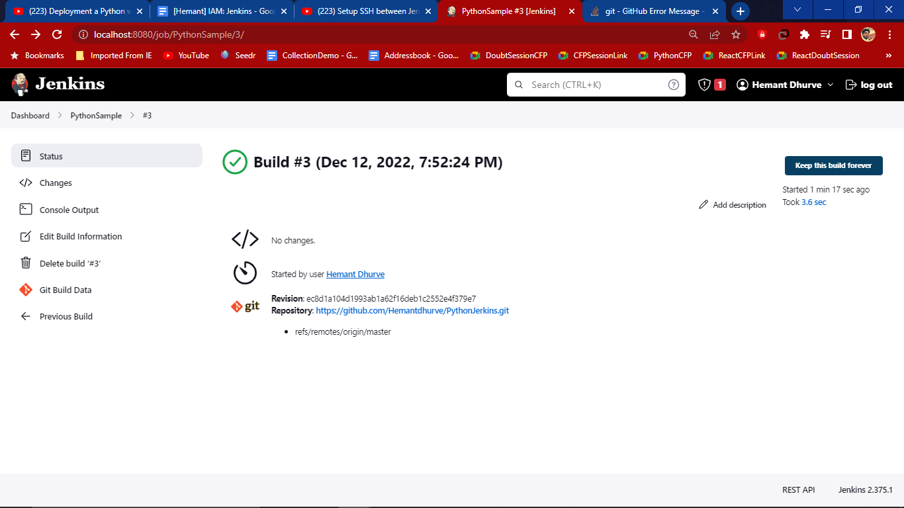

1. Go to console and use command - **find / -name "config.xml" | grep "jenkin"**

We will get a log

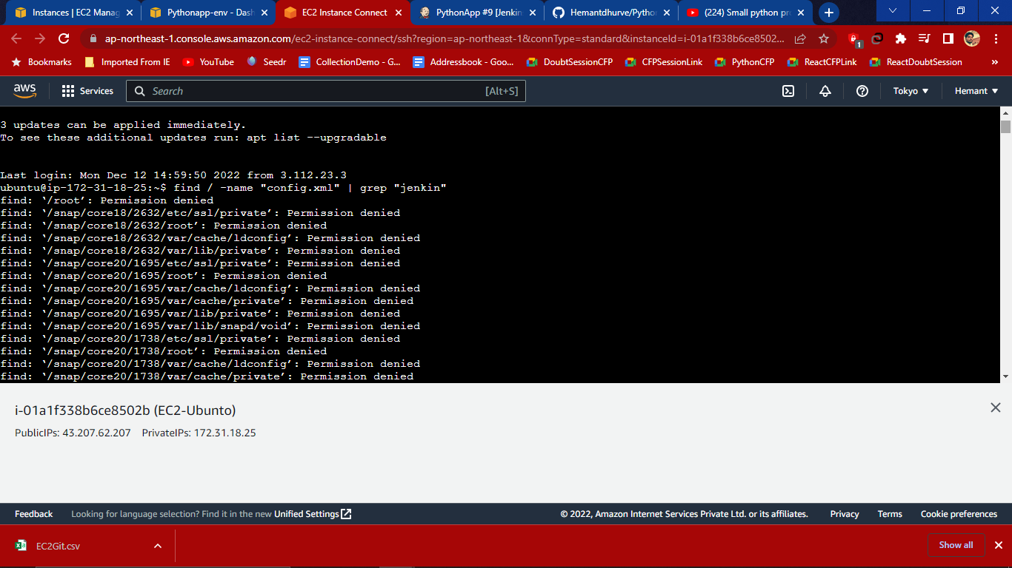

# Installation on Linux EC2 ?

1. Create Instance first or if you have created linux instance then in security add inbound rules.
2. To open **putty** we have open puttygen and generate .ppk file for the putty to run because we have downloaded .pem file while creating instance so putty **convert .pem file to the .ppk file** by following some steps browse key and save

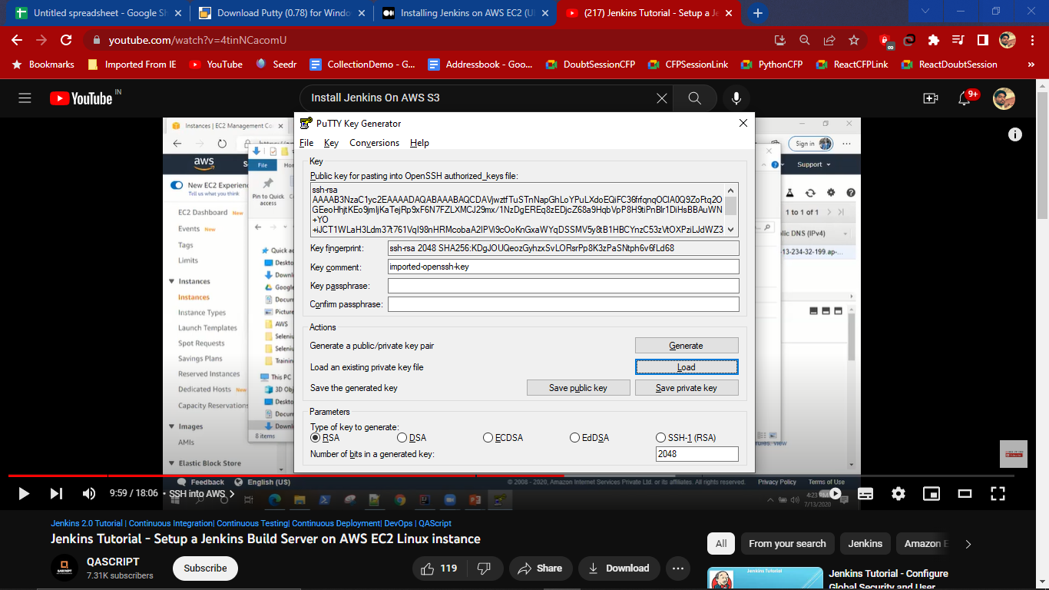

Then the putty terminal open like this where we use commands 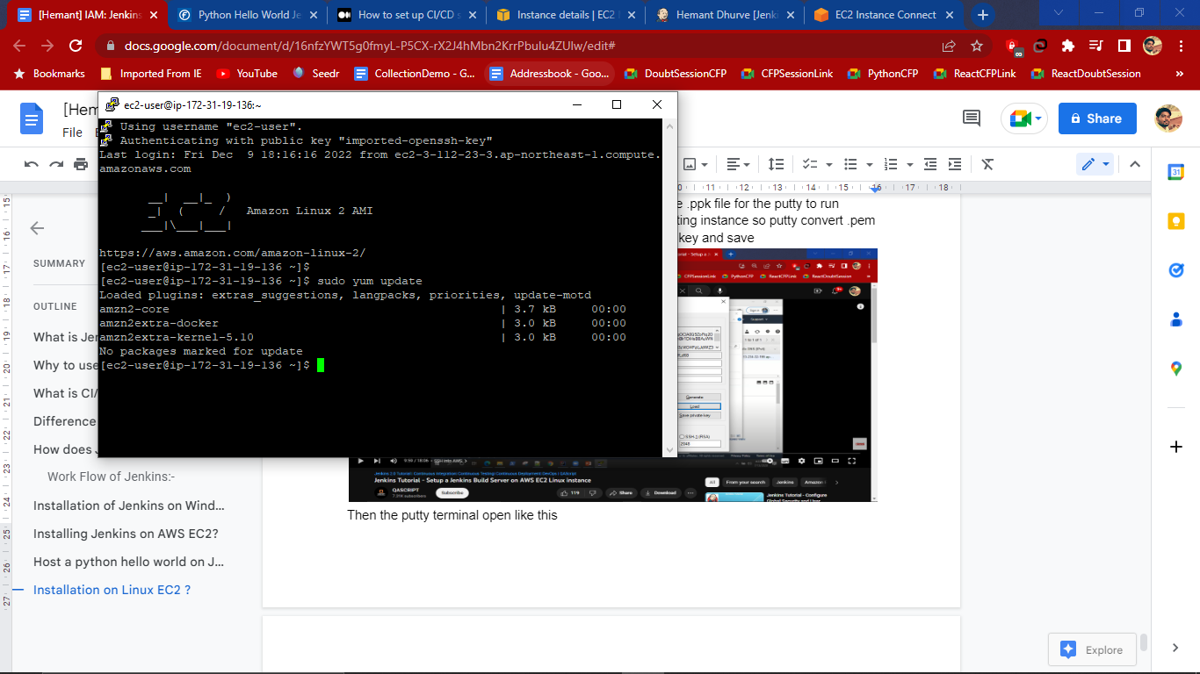

Now steps to install jenkins as follows

1. To update software packages on ec2 server use - **sudo yum update**
2. Now add jerkins repo where it’ll download jerkins repo use command -

**sudo wget -O /etc/yum.repos.d/jenkins.repo https://pkg.jenkins.io/redhat-stable/jenkins.repo**

Then add key

**sudo rpm --import https://pkg.jenkins.io/redhat-stable/jenkins.io.key**

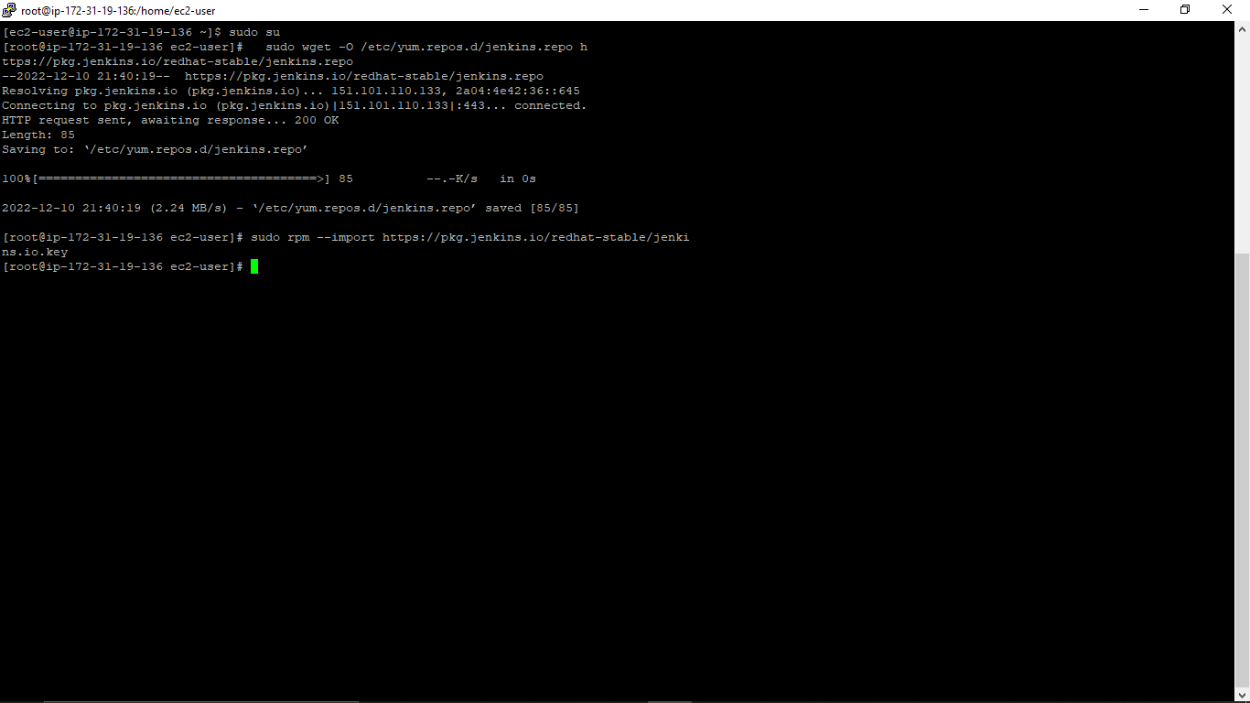

1. Then use command to install java - **yum install fontconfig java-11-openjdk**

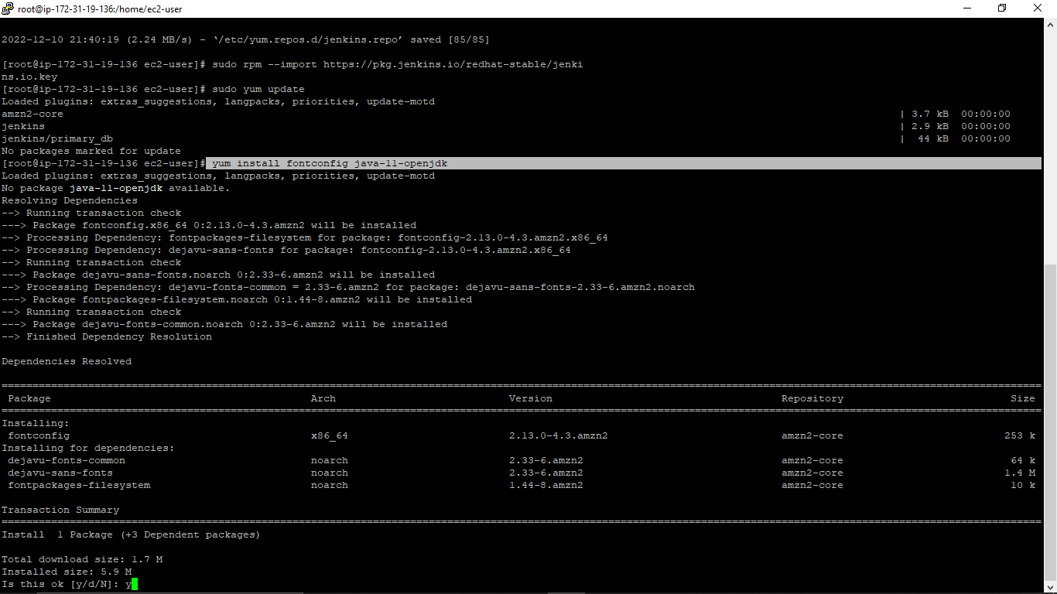

1. We need to install jenkins using- **yum install jenkins** after successfully downloading java

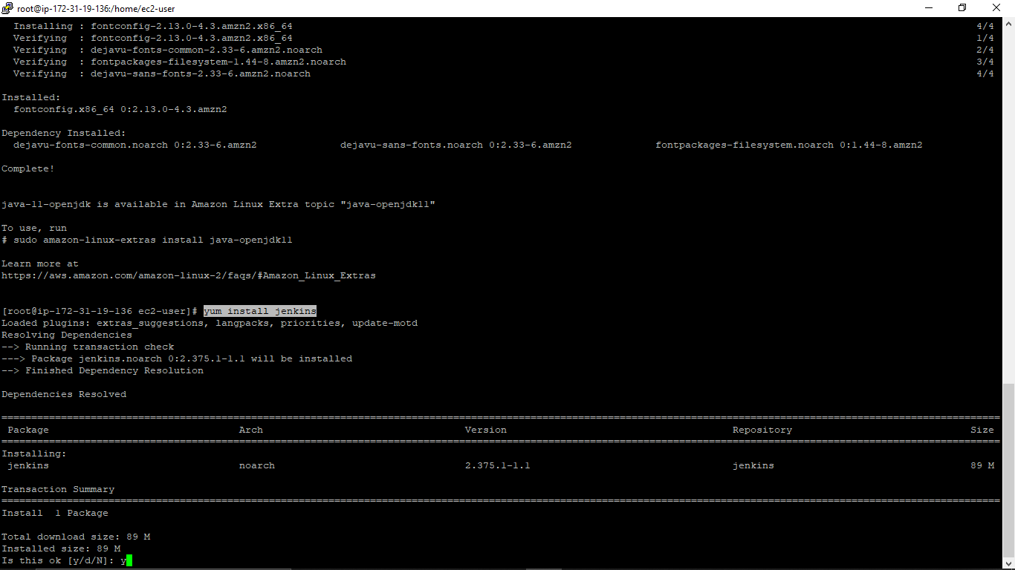

1. To check service of jenkins use - **service jenkins status if ok** then we can check in web or if not then

**1**. Check the java version

2.perform some commands**- sudo chkconfig --add jenkins**

**sudo update-alternatives --config java then**

**3.sudo service jenkins start**

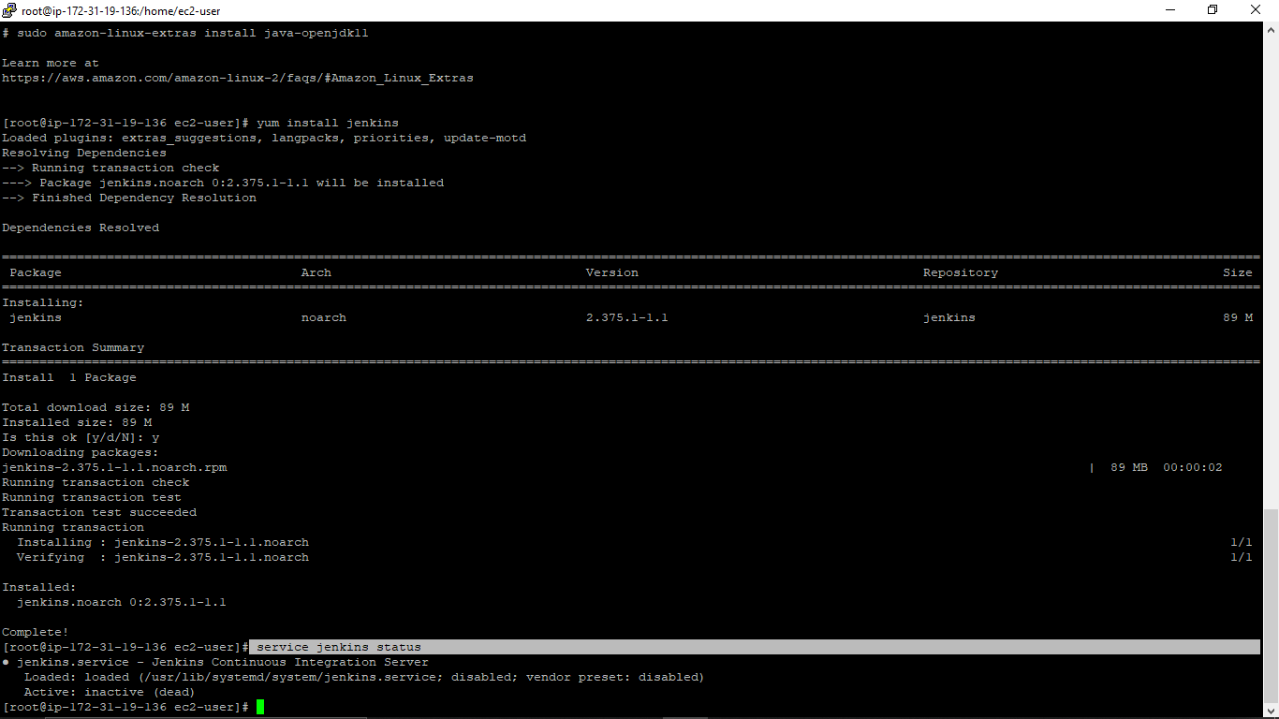

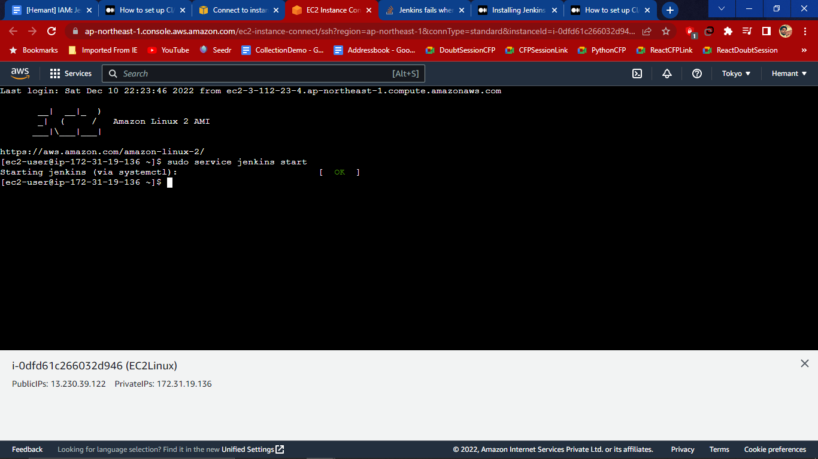

1. Now to Access Jenkins server using the public DNS of your ec2 on port 8080

Go to the **public DNS** of of EC2

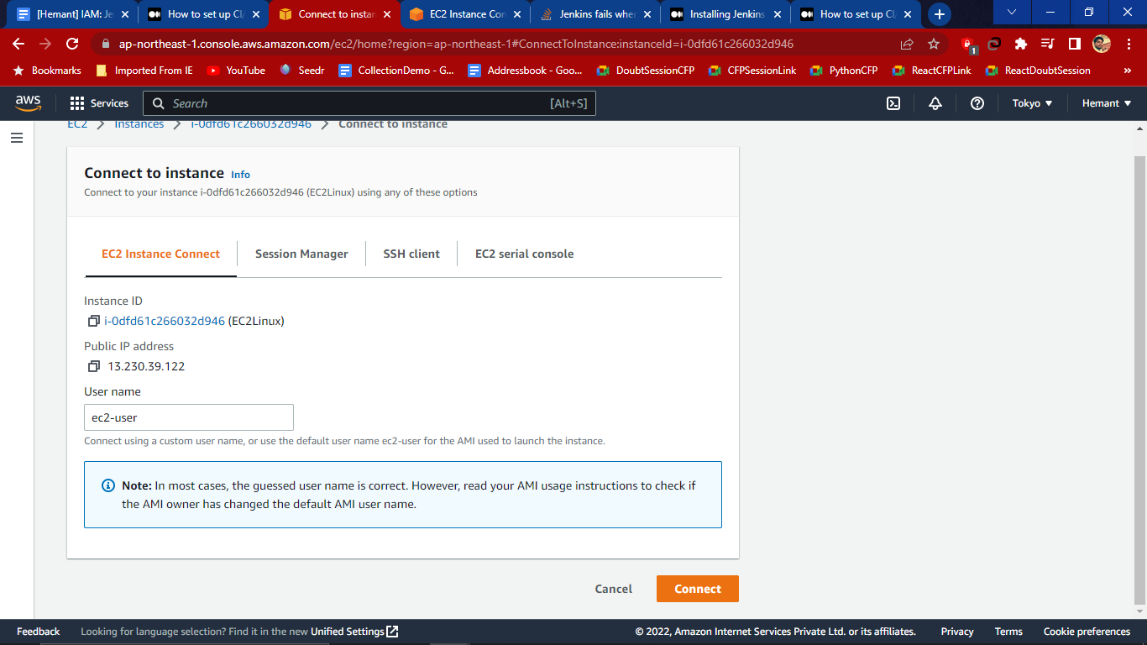

1. Now when using a public ip with port 8080 jenkins page opens in the web browser.

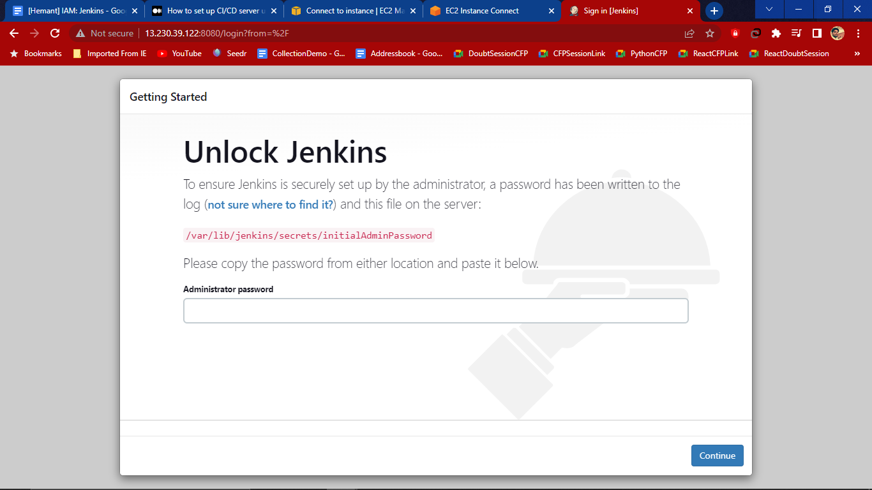

1. Now to fetch initial admin password use the command - **cd /var/lib/jenkins/secrets/ then use cat initialAdminPassword** and hit enter so that we will get the key

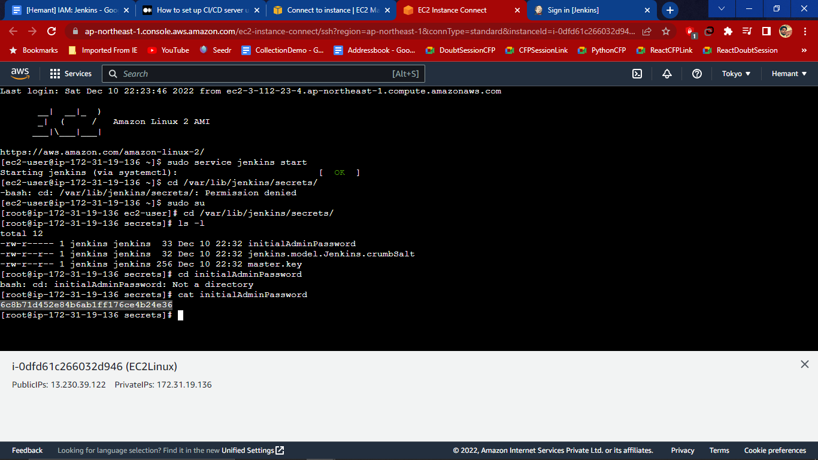

1. Use this key in the jenkins password and install and create user

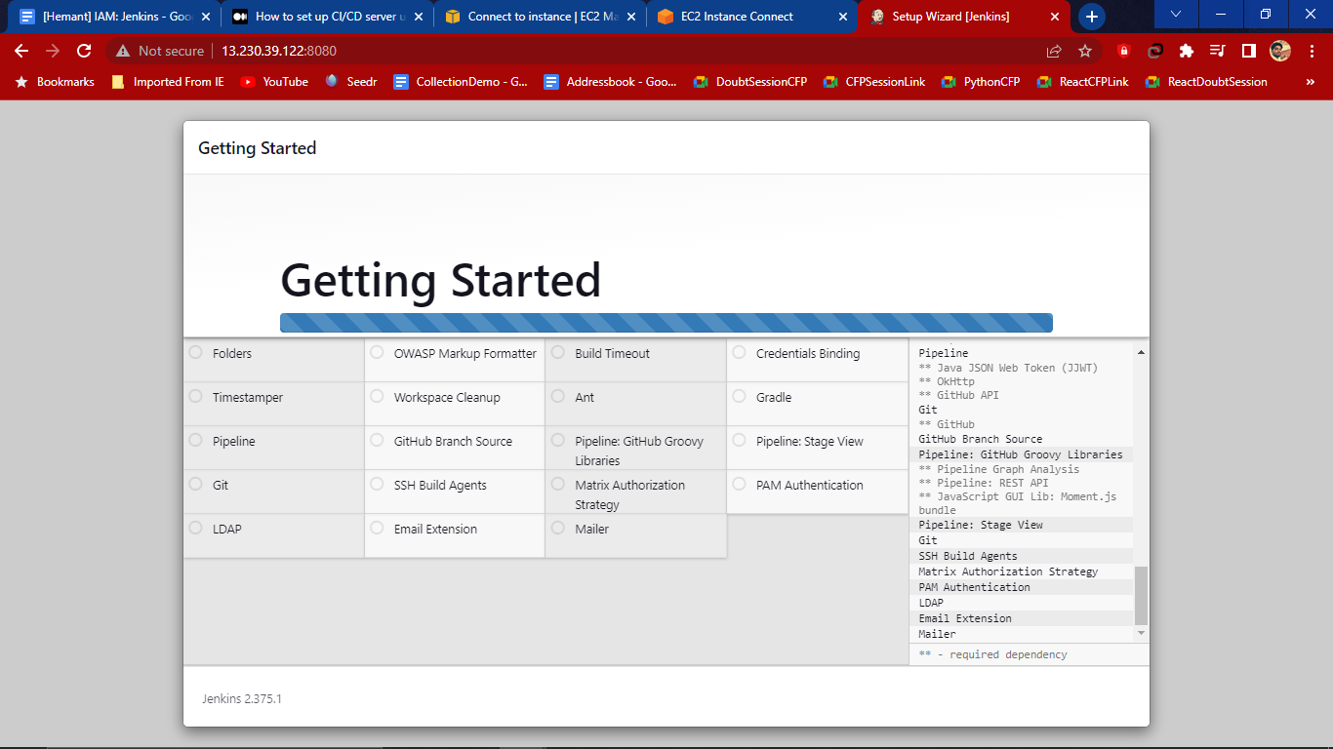

1. Now we get the jenkins url

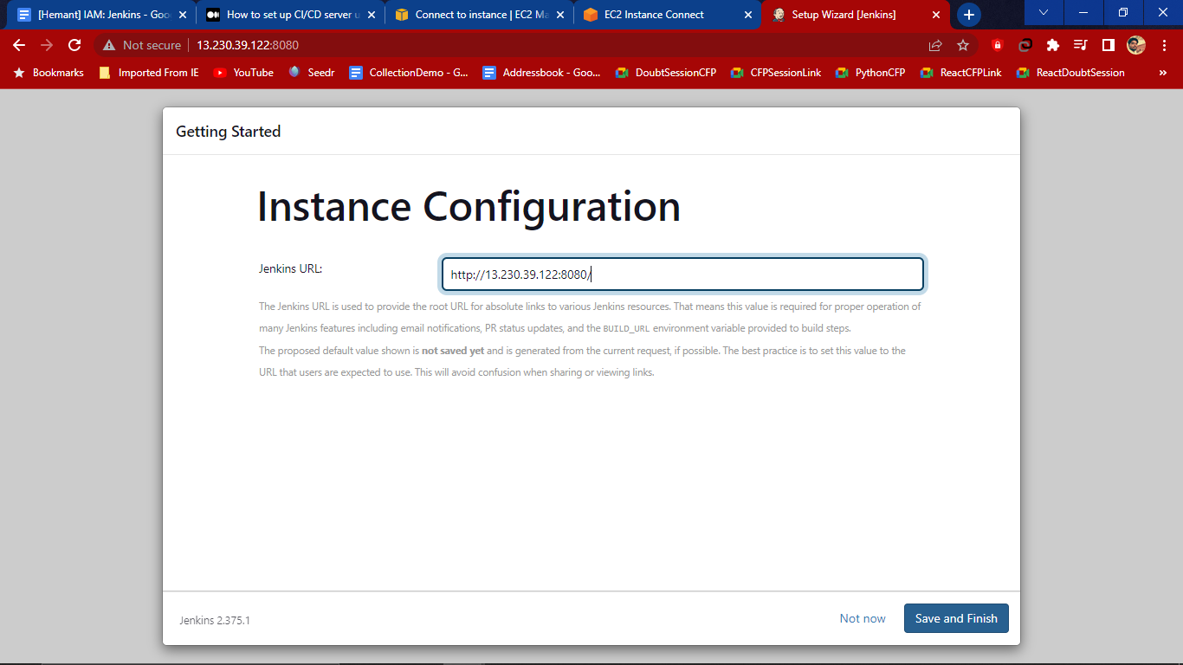

1. Jenkins dashboard appears in the browser

